TCF for Dummies: a Beginners Guide to the TCF

Introduction
Target Audience

- JSPs
What is a JSP
Purpose of a JSP & Place in the overall scheme of the TCF environment
Comment constructs
Import Statements
JSP:Usebean clause
Includes
Java variable declarations
Stylesheet declaration
Javascript declarations
Form Name
Hidden variable declarations
Button include file
HTML constructs
Including subordinate JSPs
Ending the JSP

- Javascript
What is Javascript
Purpose of Javascript & Place in the overall scheme of the TCF environment
Comment construct
Function declarations
JSP Variable references
Javascript Variable references
Executable instructions
If/Else constructs
Enter key event
Invoking the Java from the Javascript
Javascript vs Java edits

- XML
What is XML
Purpose of a XML
Place in the overall scheme of the TCF environment
Component construction
Comment Construct
Configuration parameters
Widget
Entry point
Exit point
Interaction Methods

- Java and Visual Age
Place in the overall scheme of the TCF environment
Your Package
Appfacade Class
Variable declarations & relationship to JSP variables
Getters,Setters and TCF introspection w/the JSP
The serviceMethod
Callback Class(s)
validate method
prepareResults method
Controller Class
Services Package
Important concept
Example for CICS transaction
Example of Service Class for UDB JDBC and Stored Procedures
Transactions Package
Building your request class CICS
Building your transaction class CICS
Constructing properties files
Constructing the XXXX.properties file
Constructing the XXXX_Buffers.properties file
Request classes for UDB and Stored Procedures
Constructing Transaction classes for Stored Procedures
Constructing a Transaction for UDB (JDBC)
Model Package
CBOM
TCF & Infrastructure

- Miscellaneous Notes
Setting up Screen Transfers
Enter
Back
Other
- Troubleshooting notes
- Concluding comments
- Proposed Addendum
Instructions for setting up websphere environment
VA Packages Needed
VA Special Parms
Websphere setup
Environmental parms on C drive

Acknowledgements

Casey Labedzki – Initial comment that caused this document to be conceived.
Invaluable explanations and making things make sense.
Suggestions on how to make this document better.

Jim Abene - Editorial & topic improvement comments
Yogesh Arora - Explaining several TCF concepts & showing me how to fix what
seemed to be impossible bugs.
Rich Berkthold - Supporting documentation, feedback & various tips.
Beth Brinati - Recognizing it’s value to the organization and allocating
time/support for it to happen.
Kim Fenn - Spending lots of time helping me identify obscure things in
the environment that must be set correctly for things to work
Jennifer Hantsbarger – topic recommendations
Jayasakharan Kizhakekalathil – Moral support and encouragement
Andrew Whittaker – Clarifying missing pieces through his own research

Introduction Back to the top

This document was proposed and written as a response to the increase in numbers of programmers learning and working in the web-development environment at Caremark. It has two objectives. The first one is to present the overall framework and conceptual environment that characterizes web-development at Caremark, and the second is to attempt to help programmers to become productive more rapidly within that environment.

The Thin Client Framework (hereinafter referred to by it’s acronym TCF) is a difficult and, at times, frustrating tool to become proficient with. My experience, and I believe it to be true of several other people at Caremark, was that it took many evening and weekend hours to learn the necessary concepts to be productive. Additionally, mainframe programmers new to the Java world have to struggle with web technologies, concepts, and methodologies. I have attempted to put the results of my experiences and those of my immediate coworkers learning this tool into writing. Hopefully, this document will make the process easier.

Target Audience
Back to the top

There are two principal audiences that I think can make use of this document. Java developers coming from organizations outside of Caremark, and Caremark mainframe developers doing first time development with the TCF. Some of the concepts presented here are going to seem fairly routine to experienced java developers, but I think you can glean some useful information. So bear with me through the familiar parts.

Graphical Overview
Back to the top

The following document was put together by Rick Berthold. It is a graphical overview of the Caremark web development environment.



Development Overview
Back to the top

Borrowing on Rick’s document from above, heres what happens from front to back when a user clicks on, for example, a Search button.

User clicks Code here Contains executes Prepares
Search button sets a ‘widget’ ‘widgets’ that methods & Requests
value execute services
methods
JSP → JavaScript → XML → AppFacade → Service →

Passes data Executes against Gets/ Processes Passes
to Transaction DB2 using JDBC, Changes result of result
CICS or Stored Data DB execution back
Procedures Passes result
→ Request → Transaction → CICS → Transaction → Request →
UDB
SP

Passes Formats for Presents
result screen results to
back display user
→ Service → AppFacade → JSP.

In the rest of this document, I will attempt to explain how to construct each of these components along with what I think are some relevent concepts.

Recommended approach to development
Back to the top

Casey Labedzki, one of the very best developers at Caremark, recommends the following approach. I had to relearn this the hard way several times before it finally sunk in. What you want to do is to get a basic screen display working for whatever component you are developing.

You start by constructing all of the JSP non-display components such as the imports, the usebean, the includes, the stylesheet, the javascript declarations, the basic hidden variables, and the three closing tags. Don’t worry about all these things mean now, it will all be described later. Then you want to put in one element displayed to the user such as an input box. Don’t put in anything else at this point. Next, move on to your Javascript member and get whatever edit for this JSP component working. Proceed to your XML member and get the 1st two necessary widgets up and running. Go to Visual Age, get your basic classes going for this JSP. Also, as part of all this, you need to construct the transfer components from the screen that calls your screen. Work on getting this to display correctly as is, and then start adding more stuff to each part of your function piece by piece.

Why do it this way? Because JSP bugs (and other ones too) can be difficult to decipher and the task becomes even more complicated when you have several bugs to fix all over the place. The big-bang approach where you build your entire JSP, then your Javascript, then your XML, and finally your Java components, lends itself to multiple errors occurring all at once. By adding a component at a time, you make it easier on yourself to find problems and fix them. Let’s start with the JSP in the next section.
JSPs
Back to the top

What is a JSP?
As per whatis.com, a Java Server Page (JSP) is a technology for controlling the content or appearance of Web pages through the use of servlets, small programs that are specified in the Web page and run on the Web server to modify the Web page before it is sent to the user who requested it.

To mainframers, it is the user-interface component that replaces the 3270 green screen interface. As could be expected, it is considerably more robust in it’s abilities than a green screen BMS map. However, with that flexibility comes a lot more complexity.

Most web applications at Caremark use Servlet technology as opposed to Applet technology to render webpages. Applets are executable programs that are downloaded from the server and run on the client side of the application as opposed to servlets which execute on the server. There are some performance problems associated with Applets. Downloading executable code and graphics can be a time consuming task on a non-broadband connection. Also, browsers sometimes crash when executing computation intensive Applets.

Caremark does have some applet applications (Formulary for example), but almost all of the new development uses Servlet technology. I believe it is for the reasons cited above. For a more complete writeup on Applets vs Servlets, see this link: applets vs servlets.

One interesting development which was posed to me as a question by Andrew Whittaker, and stated positively to me by John Cerwin, is the reemergence of ‘fat-clients’. It’s too early to tell, but with the emergence of widespread broad-band usage, the need for having a ‘thin-client’ isn’t as compelling. It’s possible in the future that Caremark will do a ‘fat-client’ implementation. Anyway, on to JSPs in the T(hin)CF environment.

Pupose of the JSP & Place in the overall scheme of the TCF environment
Back to the top

The JSP is the interface between the end-user and the rest of the components in the TCF. It’s what’s known as the ‘front-end’ of the system. It typically contains HTML, javascript, and Java.

Below is a JSP (see included JSP below) I put together. I am going to explain every element in it starting from the top. You should be able to use the contents of this writeup to construct a basic JSP from scratch for the TCF.

Take a couple of minutes, open this JSP with the text editor of your choice, and browse it.

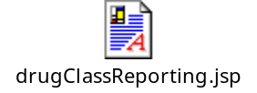

Because HTML is currently such an integral component of JSPs at Caremark, you may like to bookmark this link in your browser: www.w3.org - html40. Use it as a starting reference guide. For those of you who are library inclined, I recommend the following two books which have found to be useful reference guides:

Sybex. HTML complete 2nd edition (Alameda, Ca. 2000)
Osborne. HTML 3rd Edition (Berkeley, Ca. 2001)

You can find the best book prices on the web here: www.bestwebbuys.com/books

Building Your JSP
Back to the top

Comment Construct (HTML)
Everyone is aware of the importance of commenting code. This is how you do it in the HTML (default) portion of the JSP.
<!--------------------------------------------------------------------------->
<!-- Java Class imports and Java Variables -->
<!--------------------------------------------------------------------------->

Import Statements
Back to the top

import statemtents are typically going to be the 1st thing you put in your JSP (after any comments at the top). Those of you with some familiarity with HTML will notice the absence of the opening <HTML> and <BODY> tags. These tags do exist, but they are in a “wrapper” JSP that invokes the JSP you are constructing. See your team architect to find out more about this wrapper JSP. The import statement is used to make the classes in a java package available to your JSP.

<%@ page import ="java.util.*" %>
<%@ page import ="com.caremark.psd.adj.pbw.drugclass.reporting.*" %>
<%@ page import ="com.caremark.psd.components.adj.pbw.*" %>

The opening and closing <% %> brackets tells the JSP that what’s encased is java code.

The @ page directive refers to the instance of the JSP page's servlet processing the current request. As per Sun: Since scripting elements are converted to programming language statements in the JSP page's servlet class, you must import any classes and packages used by a JSP page. If the page language is java, you import a class or package with the page directive:

Imports can also strung together in one statement like this:
<%@ page import="java.util.*, cart.*" %>

For readability purposes, you may wish to construct your imports one per line. I certainly recommend it.

JSP:Usebean clause
Back to the top

Typically on our project, the Usebean clause is the next line of code in a JSP after the import statements. As per Sun on Usebean tags: the Usebean clause locates or instantiates a bean with a specific name and scope.

<jsp:useBean id="aTCFAppFacade"
class="com.caremark.psd.adj.pbw.drugclass.reporting.AppFacade"
scope="request">
</jsp:useBean>

Here we have a jsp open tag; a usebean declaration consisting of an id, a classs associated with that id, a scope; and a close tag. Notice that the id, class, and scope parameters are within quotes. Also, this usually appears all on one line. I chopped it into 4 lines here for readability purposes in this document.

The class is associating your Java AppFacade class (more on this later) to the JSP. The scope default is “page” if not specifically declared to be something else. Here we declare the scope to be “request”. A scope of “page” limits the reference to the JSP only and, in the TCF framework, we want our JSP to be able to reference variables and methods (user defined functions in java) in our java appfacade class. A scope of “session” forces every id referencing an appfacade class to have a unique name. Because each JSP is almost always associated with one appfacade, we prefer to use the generic tag of “aTCFAppFacade” to make the reference associations. For a more complete treatment of Usebean, see the link above. Suffice to say, use scope=”request” and save yourself some grief.

Includes
Back to the top

The following included file is a PBW convention, and may or may not apply to your project. Check w/your architect. If this doesn’t apply, go ahead and skip past the section about comp_init. You do need to know how to include files however.

The next line we see in our JSP is typically the following line:

<%@ include file="../../comp_init.jsp" %>
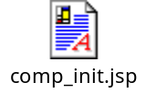

This file contains some javascript and some code that sets the formname & focuspoint on the JSP to their corresponding values on the AppFacade class in java.

As per Sun on the include directive: The <jsp:include> element allows you to include either a static or dynamic file in a JSP file.

The ../../ means up 2 directories from the current directory where the JSP would normally look for the file. Depending on your directory structure, you may need only 1 ../, or you may need more than 2.

The default directory structure on the midrange, and I believe this to be true for all of Caremark, is:

/appl/client_server/vers/clnt_webapp/Your project name here/jsp/Typically 1+ subdirectories containing JSPs.

On your computer, where you are constructing and testing locally, the default directory structure is:

C:\appl\client_server\vers\clnt_webapp\Your project name here\jsp\1+ subdirectories containing JSPs.

For Example:
C:\appl\client_server\vers\clnt_webapp\pbw\jsp\tools\drugClassReporting

Notice that on your local platform (localhost), the \ is used, and on the midrange the / is used. This is because your computer uses Windows NT, and the midrange uses Unix for an operating system.

Important: If you use an include that refers to files in other directories, make sure to use the Unix ../ as opposed to the NT ..\ - NT will accept either, but Unix will not. This has caused more than one problem at migration time. Pay attention to this when you put these together and use the Unix convention.

Java variable declarations
Back to the top

The next construct that appears in a PBW (recommended for other projects) is something like the following:

<%
String action = (aTCFAppFacade != null)?aTCFAppFacade.getAction():"" ;
String formName = (aTCFAppFacade != null)?aTCFAppFacade.getFormName():"" ;
%>

This construct is declaring 2 java String variables, action and form name. As stated previously, <% %> brackets enclose java statements. As part of the declaration, we are setting them equal to their corresponding values on the Appfacade class associated with the useBean id=”aTCFAppFacade”.

As in the example above, you can have more than one executable line of java code in a JSP java block. Each line should be terminated with the ; just like you normally do with a line of java code.

Other java variables can be defined to the JSP also using this convention. Typically, what you do is to define a java variable, and then set it’s value by invoking some method from your Appfacade class (discussed later). Why do you want to do this? Sometimes you want to use the value/contents of the java variable to populate something in the JSP.

For example:
//--------------------------------------------------------------------------->
//-- Drug Group Select Box -->
//--------------------------------------------------------------------------->
String listOfDrugGroups = aTCFAppFacade.getListOfDrugGroups() != null &&
aTCFAppFacade.getListOfDrugGroups() !="" ? aTCFAppFacade.getListOfDrugGroups():"System UnAvailable";

This executes a method on the Appfacade that builds an HTML Drop Down List Box in the contents of a string (Not a recommended technique, but it serves for illustrative purposes). If the result is null or empty, listOfDrugGroups is set to “System UnAvailable”.

Later in the JSP the String listOfDrugGroups can be used in an HTML <TD> block like this: <td colspan="2"> <%= listOfDrugGroups %> </td>

Something else to observe about the above is the use of java comments instead of JSP comments. When inside a java block denoted by <% and %>, you should use java comment blocks for your comments as opposed to JSP (HTML) comment blocks.

Stylesheet declaration
Back to the top

It is recommended that you use a Cascading Style Sheet (CSS) when constructing your JSP’s to standardize typography and page layout controls over your application. According to whatis.com (CSS): A CSS is a Web page derived from multiple sources with a defined order of precedence where the definitions of any style element conflict.

A less gobbledygook definition is that a CSS is primarily used to associate font types with elements in your JSP.

Here is how you include your projects css into your JSP:

<!--------------------------------------------------------------------------->
<!-- Style Sheet declaration -->
<!--------------------------------------------------------------------------->
<link rel="stylesheet" href="/pbw/images/pbw.css">

<link> is an HTML tag that “Establishes relationships between the current document and other documents”. The rel is a parameter within the link tag that “defines the relationship you are establishing between the current document and another resource”. The href tells it where to go look for this ‘other resource’.

The directory above is buried under /appl/web/client/, so the fully defined filename and path is /appl/web/client/pbw/images/pbw.css. Again, note the use of the Unix /. Follow the same convention when creating your own stylesheet.

Here is the PBW stylesheet declaration:

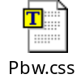
Take a couple of minutes, open it with with the text editor of your choice, and look at it.

Javascript declarations
Back to the top

Following the stylesheet declaration is/are the Javascript declarations. These declarations refer to Javascript members that contain functions your JSP is going to use. The format is as follows:

<!--------------------------------------------------------------------------->
<!-- Javascript declarations -->
<!--------------------------------------------------------------------------->
<script language="javascript"
src="/pbw/javascripts/drugClassReporting.js">
</script>
<script language="javascript"
src="/pbw/javascripts/highlightError.js">
</script>

The Script opening and closing tags tell the JSP that what’s encased is one of the scripting languages such as Javascript or VBScript. You need to declare the language. In the above example, the actual javascript is in an external file referenced by the src directive. You could have just as easily put the javascript in the block. Also note that pbw/javascripts is buried under /appl/web/client/. Your directory will be something like the following:
/appl/web/client/your project/javascripts. The external files should always be used for javascripts that will be used by more than one JSP. For javascripts speciffic to your JSP, you could put them in enclosed javascript blocks, or you could also put them in an external file too. It’s a matter of personal preference. I personally prefer to keep my javascript functions in an external file.

Form Name
Back to the top

Forms should be named. No surprise.

Here’s the construct:
<!---------------------------------------------------------------------->
<!-- Form Name declaration -->
<!---------------------------------------------------------------------->
<form action="<%= action %>" method="get" name="<%= formName %>">

the Strings action and formName were defined above and are used here. Notice that these java strings are referenced within <%= %> brackets this time. This is because ___

I believe the action parameter is used here to invoke a method determined at runtime by the TCF. Method’s we use are either be “get” or “post”. “When you use METHOD=GET, the form data is given to the form processor in the form of an environment variable(QUERY_STRING). When you use METHOD=POST, the form data is given to the form processor as the standard input to the program.”

Most of the time you will use GET, although there are instances when you will use POST – I believe usually for JSP’s that render the read-only results of some lookup request.

For the really curious:
Other methods are: Options, head, put, delete, trace. To my knowledge, you don’t have to worry about these to develop JSPs in our TCF.

The variable QUERY_STRING referenced above “is that text in the URL following a question mark. This environment variable will contain that text. SE:WSE will unwrap it and present the individual items as variables you can access directly.”

SE:WSE is ScriptEase:WebServer Edition which you can read more about at SE:WSE Manual - Introduction.

Hidden Variables
Back to the top

Hidden variables are variables that the user doesn’t see on the screen when it’s displayed. This is actually an HTML declaration. You can read more about this here: html input box.

Here are three constructs:
<!--------------------------------------------------------------------------->
<!-- Hidden Varible input type declarations -->
<!--------------------------------------------------------------------------->
<input type="hidden" name="widget" value="viewDrugClassReporting">
<input type="hidden" name="buttonClicked" value="">

<input type="hidden"
name="boBrandNameDrug" value="<%= aTCFAppFacade.isBoBrandNameDrug() %>">

The 1st construct is mandatory. It defines a widget that is going to be used in the XML (more on this later). We usually put this one right beneath the form name.

The 2nd construct is an ‘input’ variable (as opposed to output, or input-output). It is used to contain the contents of whatever button the user clicked on the screen so that the Java AppFacade class in the TCF can use it for further processing. If you declare a variable in the AppFacade with this exact name, and give it a setter method, the TCF will automatically set this for you when executing methods on the AppFacade.

The 3rd construct is an example of a variable that could be either an output variable or an input-output variable. This depends on whether you have a setter method in your AppFacade class. The value is determined by executing the Jave method inside the quotes. Note the <%= %> construct to declare that whats inside is Java code, and the use of the generic aTCFAppFacade label to refer to your speciffic AppFacade class.

Button include file
Back to the top

This file is optional, but at a project level, you probably want to think about doing something like this. On the PBW project, a decision was made to encapsulate all of the button names, associate integer values to each name, and contain them in one file that would be included in each JSP. The names were derived by common actions. Then a java Interface was created containing all of the button name and their associated values.

The construct:
<!------------------------------------------------------------------------>
<!-- Button names and values -->
<!------------------------------------------------------------------------>
<%@ include file="../../plan/button_names.jsp" %>
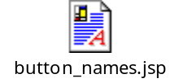

refers to a file, button_names.jsp, that is up 2 directories from the current one and down one (plan). As stated before (I’m sure at this point I’m starting to sound like your mother), pay attention to the direction of the /’s.

Here are some of the contents:

<input type="hidden" name="buttonClicked" value="0">
<input type="hidden" name="DETAILS_BUTTON" value="<%= aTCFAppFacade.DETAILS_BUTTON %>">
<input type="hidden" name="SEARCH_BUTTON" value="<%= aTCFAppFacade.SEARCH_BUTTON %>">
<input type="hidden" name="CREATE_BUTTON" value="<%= aTCFAppFacade.CREATE_BUTTON %>">

Notice the use of hidden variables and the value declarations. These values are contained in this Java Interface (which can be viewed in Visual Age for Java - you will need to add this project to your local workspace):

com.caremark.psd.components.adj.pbw.IPBWConstants

Here are some declarations inside that Interface:

// IButtons & events ← Java comment
int DETAILS_BUTTON = 0; ← Use of all caps to declare a constant.
int SEARCH_BUTTON = 1;
int CREATE_BUTTON = 2;

HTML Constructs
Back to the top

It’s not my intention to write an HTML tutorial here as so many have already done a much better job than I will ever be able to do. See the link near the top of the JSP section of this document for a good starting place. What I do want to do is list the constructs, not already covered above, you should know about. Also some examples of how they are used.

The big three:
table - <table>, </table>
table row - <tr>, </tr>
table cell <td>, </td>

Another useful one:
bolding text - <b>, </b>

<!------------------------------------------------------------------------------------------>
<!-- Report Request Information table -->
<!------------------------------------------------------------------------------------------>
<table cellspacing="2" cellpadding="2" border="0" width="490">
<!------------------------------------------------------------------------------------>
<!-- Request Id Label and Input Field -->
<!------------------------------------------------------------------------------------>
<tr>
<td><b>Request ID:</b></td>
<td colspan="2">

Using java, see if inputReportRequestId contains a non-zero value. If so, display the input text box w/the value. If not, do a default display. Notice the use of events and actions to take. The events are HTML events associated w/input boxes. What’s contained within the single quotes are Javascript actions. The Javascript invocation is enclosed in single quotes and uses the syntax: document.formName within parentheses.

<% if (aTCFAppFacade.getInputReportRequestId() != null
&& !aTCFAppFacade.getInputReportRequestId().equals("0") ) { %>
<input type="text"
name="inputReportRequestId" size="10" maxlength="10" align="left"
value="<%= aTCFAppFacade.getInputReportRequestId() %>"
disabled
>
<% } else { %>
<input type="text" name="inputReportRequestId" size="10" maxlength="10"
align="left" value="" tabindex="1"
onChange='return setWidgetValueGetRequest(document.drugClassReportingForm)'
onKeyPress='return requestIdTestForEnter(document.drugClassReportingForm)'
>
<% } %>

Notice below the use of ‘type’. This is referring to a declaration in the stylesheet.

<input type="button" name="get" value="Get" class="buttons"
onClick='return setWidgetValueGetRequest(document.drugClassReportingForm)'
tabindex="2"
>
</td>
</tr>
</table>

Here is the buttons declaration from the css:
.buttons {
FONT-FAMILY: Verdana, Arial, Helvetica, sans-serif; FONT-SIZE: 9pt;
FONT-STYLE: normal; FONT-WEIGHT: normal
}

Including subordinate JSPs
Back to the top

It’s possible to have JSP’s contained within JSPs. In fact, this is a very common practice.

It’s done like this:

<%@ include file="drugClassReportingConstraints.jsp" %>

They can also conditionally be included based on variable values in your AppFacade like this:

<% if( aTCFAppFacade.getRadioReportType().equals("1")) { %>
<%@ include file="drugClassReportingConstraints.jsp" %>
<% } %>

One thing to keep in mind with application JSPs when you do this. A JSP gets compiled at runtime the 1st time it gets used. If you make changes to JSPs, the run-time machine recompiles the JSPs that get changed. Except when they are JSPs within JSPs. This can trip the unwary who doesn’t understand why their change to an ‘included JSP’ is not being reflected in the behavior of a screen.

You must force the virtual machine to recompile the containing JSP to pick up the change. Two options are to make a cosmetic change to the outside JSP, or delete it to force a recompile. If it is on the Unix box, you can ‘touch’ it. See the troubleshooting section for more on this.

Ending the JSP
Back to the top

At the end of the JSP are three closing tags:

</form>
</BODY>
</HTML>

that do not have corresponding opening tags at the top. Why? Because your JSP is contained in a container(wrapper?) JSP. Mercifully, the problem described above doesn’t apply to changes in your JSP. However, you need to be aware that you should close your JSP with the above construct. Enough said. Now on to Javascript.

Javascript
Back to the top

What is Javascript
Javascript, as it’s name implies, is a scripting language. Another such scripting language is Perl. However, we are using javascript as part of the TCF. Javascript is not Java although, to confuse matters, some of the constructs are similar. If you really want to delve into this, a good resource to start with is: javascript language.

Books that I have in my library are:
Osborne. JavaScript, A Beginner’s Guide (Berkeley, Ca. 2001)
Osborne. JavaScript The Complete Reference (Berkeley, Ca. 2001)

Purpose of Javascript & Place in the TCF Framework
Back to the top

The purpose of Javascript within the TCF framework is to perform edits and non ‘business layer’ tasks. It is also used to set ‘widgets’ in the XML (covered in that section) which in turn invoke callbacks and methods on the TCF. Finally, it ‘submits’ requests to the server to process after the widget has been set in the XML.

If you are going to use a lot of Javascript, the following tool which Keith Patel made aware to the PBW group will be useful:

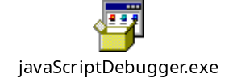

It’s Microsoft’s Javascript debugger tool. Clicking on it will install it on your computer, and it works with Internet Explorer. After it’s installed, it will give you popup boxes when it encounters errors. If you reply yes to the popup box, 90% of the time it will open up document on the line that caused the problem. But not always.

When you are developing on your desktop, Javascripts are stored in the following directory structure:

C:\appl\web\client\Your Project\javascripts

I am going to cover some of the basic Javscript constructs here, but it is strongly adviseable to do a little more work with a tutorial on the web or a good book on the subject.

As with the JSP section above, below is a sample Javascript document. Take a couple of minutes to review this document with the text editor of choice, and I will explain pertinant pieces of it below.

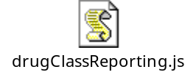

Comment construct
Back to the top

Comments in Javascript are done like this:
//-----------------------------------------------------------------------------
// Validations
//-----------------------------------------------------------------------------

Function declarations
Back to the top

Javascript Functions are typically what is called from within the JSP to execute. The declaration looks like this:

//-----------------------------------------------------------------------------
// Buttons
//-----------------------------------------------------------------------------
function setWidgetValueGetRequest(form) { executable javascript here...}

In this function, the object form is passed in. If you look above in the JSP section, you can find this:

onChange='return setWidgetValueGetRequest(document.drugClassReportingForm)'

where the inputReportRequestId was declared.

In the JSP, Javascript was being invoked and the entire form was being passed in as a parameter. Here in the Javascript, we are declaring that function and receiving an object named ‘form’ as a parameter. It’s possible to pass in only one variable on the form instead of the entire form. Feel free to do it that way if you prefer.

The JSP would be look like this:
onChange='return
setWidgetValueGetRequest(document.drugClassReportingForm.inputReportRequestId)'

And the Javascript would look like this:
function setWidgetValueGetRequest(number) { executable javascript here...}

You could still call it ‘form’ inside the parentheses, but you should use a parameter marker that’s more descriptive of what’s being passed. Anyway, you can also see that it’s more typing. However it does save the amount of space in memory used to pass parameters back and forth between the JSP and Javascript.

JSP Variable references
Back to the top

You oftentimes execute Javascript to edit a variable on a JSP. You use the syntax form.variableName.value Such as in this example:

if(form.inputReportRequestId.value < 0 || form.inputReportRequestId.value > 214748364)

The JSP variable inputReportRequestId has it contents examined by using it’s value property.

Here’s another way to do it

form["inputClientCode"].value = form["inputClientCode"].value.toUpperCase();

I prefer the 1st way, but it’s a matter of personal preference.

Javascript Variable declarations
Back to the top

Your Javascripts will typically contain three primitive datatypes: boolean, number, and string. Because Javascript is ‘weakly typed’, you will find that sometimes a variable that you thought was a number is being treated as a string. This can play havoc when you are doing comparisons. Believe me, I know. I spent several hours one day trying to figure out why my comparison wasn’t working.

Example:
//-------------------------------------------------------------------------------
// Comparison to Minimum Days Supply edit
//-------------------------------------------------------------------------------
// explicitly cast these values to javascript numbers - without this, 120 is < 30
//-------------------------------------------------------------------------------
var maxDaysSupplyNum = parseInt(form.maxDaysSupply.value);
var minDaysSupplyNum = parseInt(form.minDaysSupply.value);

Here we are declaring the contents of two variables to be parsed as integer values from two variables in the JSP that were passed in on as properties of the object named ‘form’. The syntax is: var; followed by the name; followed by whatever value you want to set it to; followed by semicolon. Give your javascript variables meaningful names.

Javascript also makes use of objects. We often use the object ‘form’ in the TCF environment to pass values from the JSP to Javascript and from one Javascript function to another.

Executable Instructions
Back to the top

Notice 2nd example above terminates with a ;. This is how you code executable instructions in javascript, the same as in java. Also note the use of the ‘=’. This also works the way java does. It assigns the contents of the right hand side to the left hand side. If you want to do an equality comparison, you use the ‘==’ (equal equal) construct. Greater than, less than, greater than or equal to, and less than or equal to are constructed with >, <, >=, and <=.

If/Else constructs
Back to the top

If constructs and if/else constructs are as per the following example:

//-----------------------------------------------------------------------------
// Invoked when the Request Id is entered
//-----------------------------------------------------------------------------
function validateRequestId(form) {
1 if (isNumber(form.inputReportRequestId)) {
2 if (form.inputReportRequestId.value < 0 ||
form.inputReportRequestId.value > 214748364) {
- alert("Request Id out of bounds. It must be between 0 and 214748364");
- return false;
5 } else {
return true;
}
} else {
6 form.inputReportRequestId.focus();
return false;
}
}

Line 1 contains the 1st test condition contained within the parentheses. It is actually invoking another javascript function named isNumber and passing in the inputReportRequestId property of the form. Also, before line 2 is an open bracket, {. I believe that this is only necessary if you have more than one line of executable code you wish to execute within the if block. I just always use it as a matter of preference.

Line 2 contains an ‘or’ construct ( || ), again within the parentheses.

Line 3 causes an alert box to be displayed to the user with the message inside the double quotes. You will probably use this quite a bit.

Line 4 causes the function to terminate passing a false condition back to the caller which could be the JSP or another javascript. Line 1 is expecting a true or a false back from the isNumber function.

Line 5 closes the if bracket with a } and starts the else part of the 2nd if construct.

Line 6 tells the JSP to put the cursor on this field when redisplaying the screen.

Enter Key Event
Back to the top

From time to time, you are going to want to know when the user pressed the entery key, or tie an action to it. To test for this event, use this:

if (window.event.keyCode == 13)

Invoking the Java from the Javascript
Back to the top

You also use the javascript to set a widget in the XML, which then interacts with the java using a Callback and a method on the AppFacade. More on this later. What’s important to know now, is how you create this construct.

Here’s an example:

function setWidgetValueSave(form) {
if (validateForSave(form)) {
1 document.drugClassReportingForm.widget.value="drugClassReportingSaveButton";
2 document.drugClassReportingForm.buttonClicked.value=
document.drugClassReportingForm.SAVE_BUTTON.value;

3 if(browser.isIE) { form.submit(); }
return true;
}

return false;
}

Line 1 sets the hidden variable widget on the JSP. It sets the value property to drugClassReportingSaveButton. This is the name of a ‘widget’ declaration in the XML (more in that section).

Line 2 sets the hidden variable buttonClicked to the value contained by constant SAVE_BUTTON (see the JSP section for more information about this).

Finally, on line 3 we execute the submit() function to start an interaction with the server and execute some Java code.

Javascript vs Java edits
Back to the top

When tasks are performed within the javascript part of the TCF as opposed to the java part, the response time is considerably faster. This is because the code is executed locally instead of sending a ‘get’ or a ‘post’ back to the server which usuall entails a transmission over the network and a screen repaint. Definitely more time-consuming. For this reason, you may wish to code your screen edits in javascript.

Having said all that, javascript can also be problematic because it does not have very good debugging tools. As per Kim Fenn, use javascript for as little as possible and save yourself a lot of headaches. It is useful for very simple edits such as field required, and numeric checks. Beyond that, unless you make up your mind that you are going to be a javascript expert, you might wish to avoid using it for much else. The tradeoff is it’s easier to code and debug an edit with java code, but you get much faster response time if you’re successful in coding it in javascript.

If you decide to have a mixture of edit types, that is some in java and some in javascript, you need to come up with an intelligent way to split the edits out. Such as: required field validations, numeric checks, and other such simple edits in javascript; and anything more complicated in java. Something to think about with this is whether you want to take care of all of your javascript edits before the your java edits. How you do this affects the behavior of the screen. Java edits typically entail screen repaints which are visible to the user and take a couple of seconds. Depending on your application, it may just be infeasible. But the way to do this is to not call any of the java edits until a user clicks on a button or the enter key. Do not code any submit() functions in your javascript functions except the button and enter functions.

XML
Back to the top

What is XML
XML, eXtensible Markup Language was originally intended to be a more robust successor to HTML. According to this link: xmlapps.htm

XML differs from HTML in three major respects:
- Information providers can define new tag and attribute names at will.
- Document structures can be nested to any level of complexity.
- Any XML document can contain an optional description of its grammar for use by applications that need to perform structural validation.

Here’s a good link for XML.

Purpose of XML
As per this link: www.infomotions.com/xml/workshop/workshop.html, the primary purpose of XML is to transmit data from one computer to another as unambiguously as possible. Once transmitted, it is up to the receiving computer to interpret the data for some useful purpose thus turning the data into information. Sometimes the data will be rendered as HTML. Other times it might be used to update and/or query a database. However, this isn’t how we use XML at Caremark.

Place in the overall scheme of the TCF environment
Here at Caremark, we use XML specify configuration data. What this essentially means is that XML tells the TCF what method in your AppFacade class (a class you define to handle interactions between the JSP and Service classes) and what Callback Class is related to a given action that the user initiates (such as clicking on a button). XML is a layer between our JSP/javascript components and our java Classes, between our desktop computers and the server.

Here is the model XML I am going to refer to in the component construction section:

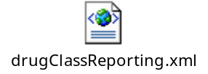

Take a couple of minutes an review it with the text editor of choice.

Also, associated with all XML’s at Caremark is the following DTD (Document Type Definition) file.

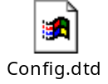

Very important
When you look at this file, pay special attention to the sections that start from <!-- component section --> (Do a search for this) and terminate with
<!-- component section -->. These elements are what you are going to create in your application XMLs. The rest of the XML writeup relates back to these components.

Component construction
Back to the top

Component declaration
All XML’s begin with the Component declaration which has the following syntax:

<component name="DrugClassReporting"
class="com.caremark.psd.adj.pbw.drugclass.reporting.Controller" facadeTag="&appName;DrugClassReportingFacade" facade="com.caremark.psd.adj.pbw.drugclass.reporting.AppFacade">

Notes
- The above is chopped onto multiple lines for readability. In the XML, it typically appears as one line.

- The name must be unique within your application. If not, it will cause problems. Trust me, I know this the hard way.

- The class refers to the controller class you will declare within your java package. In this case, the package is com . caremark . psd . adj . pbw . drugclass . reporting, and the class is always Controller (more on this in the java section).

- facadeTag should follow the above syntax. The rule appears to be that the Facade takes on the name plus the appellation Facade.

- facade refers to your AppFacade class within your package. It should always be called AppFacade.

- The entire document is the component, so the closing component tag is at the end of the XML.

Comment Constructs
Back to the top

Comments in XML are encolosed in a block like this: <!— your comment here --> .

ConfigParam
Back to the top

Immediately following the component name are the configParams if there are any.

Here’s an example:
<!-- ********************************************************************** -->
<!-- One of these is needed for each service invoked from the Appfacade -->
<!-- ********************************************************************** -->
<configParam name="DEBUG" value="true"></configParam>

<configParam
name="drugClassReportingServiceName"
value="&appName;DrugClassReportingService">
</configParam>

Notes:
- The 1st configParam appears to be optional. My XML has it, but plenty of others don’t.

- You don’t need configParams unless you’re java code is going to execute CICS transactions! SQL services to UDB databases and to Mainframe Stored Procedures don’t use them.

- configParams (configuration parameters) consist of two attributes, a name and a value. The name refers to an attribute called name in the Service Class designated for your CICS transaction, and the value refers to the Class itself.

- I need to digress here for a second and get ahead of myself (again). Going back to Berthold’s document on page 4 is a diagram. On the right hand side of the diagram is a green box captioned service that has 1 arrow pointing off to Transaction, and one arrow pointing off to DB2. Actually, the diagram should probably look like this: Service → Request → Transaction → DB2. All interactions with DB2 in the TCF make use of 3 java classes: a service class, a request class, and a transaction class. Back to this, the service class is what we are defining in the configParams piece of the XML.

- the attribute values are enclosed in double quotes.

- The configParam is terminated with a closing > and then with a </configParam>. Remember to follow this convention because it can be painful to decipher if you forget and your screen doesn’t render properly.

EntryPoint
Back to the top

Next is the entryPoint declaration.

You will probably always have a minimum of two entryPoints. Your ‘render’ entryPoint, and your initial ‘view’ entryPoint. This is a convention widely used in PBW. You don’t have to do it this way, but I think it makes the explanations easier to follow. I recommend sticking with this convention to avoid unnecessary difficulties with your 1st few XMLs.

Coding the ‘render’ entryPoint
<!-- ******************************************************************************* -->
<!-- Render Entry Points -->
<!-- ******************************************************************************* -->
(A) <entryPoint widget="renderDrugClassReporting"
method="com.caremark.psd.adj.pbw.drugclass.reporting.RenderCallback"
serviceMethod="doNothing"
callback="YES">
(B) <exitPoint name="renderDrugClassReporting">
<interactionMethod class="jsp"
method="/pbw/jsp/tools/drugClassReporting/drugClassReporting.jsp">
</interactionMethod>
</exitPoint>

(C) <exitPoint name="renderError">
<interactionMethod class="jsp"
method="/pbw/jsp/tools/drugClassReporting/drugClassReporting.jsp">
</interactionMethod>
</exitPoint>

<!-- ****************************************************************************** -->
<!-- Transfer renderers -->
<!-- ****************************************************************************** -->
<!-- Find Client -->
<!-- ****************************************************************************** -->
(D) <exitPoint name="renderFindClient">
<interactionMethod class="comp"
method="?widget=renderPbwFindClientScreen&amp;sel=0">
</interactionMethod>
</exitPoint>
</entryPoint>

Notes:
widget
- I recommend the first entryPoint declaration to always be your ‘render’ entryPoint. As shown by (A) above, entryPoints take four parameters: A widget which corresponds to a hidden variable in your JSP (look for widget in the JSP section); a method which corresponds to a class in your java package (Callback classes which will be covered in the Java section); a serviceMethod which is declared in your AppFacade Class; and a callback which is always set to yes (to the best of my knowledge). Your render widget should be called renderYourPackageNameHere.

One additional word about widgets. They must be uniquely named within an application. Failure to do so results in unexpected screens rendering. This can be a very confusing experience. Stated again: All widgets should be uniquely named.

exitPoint
- Within each entryPoint block, you define one or more exitPoint Parameters. These exitPoints are what gets done next after you do whatever you do inside the entryPoint (sorry for the stupid explanation). As shown by (B) and (C) above, exitPoints have a block within them called an interactionMethod.

interactionMethod
- The interactionMethod takes two paramaters, class, and method. I have only seen class take on the two values jsp and comp. You use class=”jsp” to get the exitPoint to ‘render’ your JSP. The method will be your jsp. Make a note of where your JSP is stored in your directory tree as you will need to define it correctly here. The class=”comp” is used to redirect/transfer flow control from one screen to another or from one XML entryPoint to another. Observe the exact syntax in 4 above. The screen that called this one has a block that looks like (D). It’s widget was renderDrugClassReporting which is the 1st exitPoint in our ‘render’ entryPoint

Coding the initial ‘view’ entryPoint

<!-- ****************************************************************** -->
<!-- Initial entry point -->
<!-- ****************************************************************** -->
(A) <entryPoint widget="viewDrugClassReporting"
method="com.caremark.psd.adj.pbw.drugclass.reporting.Callback"
serviceMethod="doNothing"
callback="YES">

(B) <service name="&appName;DrugClassReportingService"
class="com.caremark.psd.adj.pbw.services.DrugClassReportingService"
resource="&appName;drugClassReporting">
</service>

(C) <exitPoint name="renderDrugClassReporting">
<interactionMethod class="comp" method="&startPainting;"/>
</exitPoint>

(D) <exitPoint name="renderError">
<interactionMethod class="comp" method="&startPainting;"/>
</exitPoint>
</entryPoint>

Notes:
The Initial entryPoint (A), is what the hidden variable widget should defaulted to on the JSP. The method parameter should be yourPackageName . Callback, the default callback class in your package. The serviceMethod should be a method on your AppFacade class that does some initial stuff upon entering the screen. In this case – doNothing.

This entryPoint has the service (B) declared a 2nd time (the 1st time was in the configParams section). This is mandatory if the service is potentially going to be used by methods from within this entryPoint. Again, if your package does not need to call CICS transactions, you can ignore this.

The exitPoint declarations here (C) & (D) refer to exitPoint declarations under the Render entryPoint. Again, they’re contained within interactionMethod blocks. Use class=”comp” and method=”&startPainting;”

At this point, you are probably asking what’s the point of all this XML stuff? And I don’t blame you. The XML functions to tie your JSP to java classes within a package you create that’s part of the TCF. You have only seen the 1st half of it. This will start to make more sense when you see the next section. So please bear with me.

I haven’t covered the element visualChild because I haven’t used this element for any of the XMLs I constructed. My guess is that you probably are not going to use it either.

Java and Visual Age
Back to the top

Place in the overall scheme of the TCF environment
Java code resides on the midrange servers between the browsers on the front-end and the mainframe databases on the back-end. In theory and generally in practice, the business logic is contained in the java code. If you’re working with CICS transactions, sometimes there’s business logic in them.

Your Package
A package in Visual Age consists of various classes that are needed to make a screen work. Sometimes more than one screen is related to a package. An example of this might be summary screens that contain an initial set of search fields and then render a list when the search button’s clicked. You, or someone designated in your group, will create a package to contain the classes for whatever screen/funtion you’re developing. Your package resides in something called a ‘Project’ within Visual Age. Usually, your team architect creates the project.

I am assuming that you know a little about navigating around Visual Age for Java. If not, you may wish to invest in one of these books:
Enterprise Development with VisualAge(r) for Java, Version 3
Author: Dale R. Nilsson(Editor), et al Format: Trade Paperback, Publication Date: May 15, 2000
ISBN: 0471389498

Programming With VisualAge for Java
Author: Marc Carrel-Billiard,John Akerley Format: Paperback, Publication Date: February 1998
ISBN: 0139113711

Interestingly, amazon.com had far cheaper prices for used copies than my normal source, bestwebbuys.com/books.

Alternatively, you might want to consider one of these links:
http://pages.cpsc.ucalgary.ca/~carman/333/VisualAgeTutorial/

IBM
IBM VA Java Tutorials page

Anyway, VA Java is where you are going to construct the classes that are acted upon by the JSP, javascript and XML. You will always have an AppFacade class, one or more Callback classes, and a Controller class. Each of these will be covered in more detail below.

The DrugClassReporting component was the primary example in earlier sections of this document. It’s probably useful to have this project handy for this piece of the document too. It can be found in the CBB project. You add it by clicking on the project button (contains a folder), checking the radio box labelled ‘Add projects from the repository’, and selecting it from the list. You may need to get an architect to give you some kind of access privelege before you can add it into your workspace. The package in this project is com . caremark . psd . adj . cbb . drugclass . reporting.

AppFacade Class
The AppFacade class, which has been repeatedly referred to in prior sections of the document, is where most of the action takes place in the TCF. At least as far as coding for you is concerned. Directly, or indirectly, it should extend the TCFAppFacade (superclass). What I mean by this is that sometimes your team architect decides to create one or more AppFacade classes for your project that extend TCFAppFacade. Due to application requirements, you to extend one of those classes instead.

You create your AppFacade class by copying someone elses that works (typical method). Oftentimes you get a lot of extra attributes and methods that you don’t need when you do it this way. So pay attention and plan ahead. You can also click on the Class wizard (C button at the top of the Visual Age screen) or right click on your package and select add and then Class. If you use the wizard, put TCFAppFacade as the superclass, unless directed otherwise by your team architect.

Variable Declarations & relationship to JSP Variables
Back in the JSP section, there were various types of variables declared. Those variables could have been in a Java block on the JSP, in a hidden variable, or directly in the HTML with a ‘name’ attribute.

Examples

Java Block on JSP
//--------------------------------------------------------------------------->
//-- Drug Group Select Box -->
//--------------------------------------------------------------------------->
String listOfDrugGroups = aTCFAppFacade.getListOfDrugGroups() != null &&
aTCFAppFacade.getListOfDrugGroups() !="" ? aTCFAppFacade.getListOfDrugGroups():"System UnAvailable";

Hidden Variable on the JSP
<input type="hidden"
name="boBrandNameDrug" value="<%= aTCFAppFacade.isBoBrandNameDrug() %>">

HTML construct – name identifies a java variable
<input type="text"
name="inputReportRequestId" size="10" maxlength="10" align="left"
value="<%= aTCFAppFacade.getInputReportRequestId() %>"
disabled
>

What’s declared in the AppFacade Class
...
private String listOfDrugGroups;
...
private boolean boBrandNameDrug;
...
private String inputReportRequestId;

Most of the time you want to declare each variable and object in the AppFacade that you declared on the JSP, and most of the time these should be declared with the same names that you gave them on the JSP. The default type should be a private String, although there are going to be plenty of exceptions to this rule.

Getters, Setters and TCF introspection w/the JSP
What is a getter and setter? Java methods. Getter and setter methods are techniques used to manipulate a variable from outside your class that has been declared private (you usually want to do this). The getter retrieves the variable, and the setter assigns it. Variables in java can be primitive data types (pdt) or objects.

If you are new to java, please take a second to read the following PDF on the difference between passing by value and passing by reference. It’s important to understand this concept (I know the hard way).


You want to generate getter and setter methods for each pdt/object you declare. Why do you need getters and setters? Because the TCF uses the setter methods to make the values on the AppFacade equal to what they are on the JSP. It uses a technique called Introspection (Studying a Javabean with reflection to discover its properties) to do this. You need getter methods to pull those values off the AppFacade and put them in your JSP when you need them. You will also sometimes use them to populate other objects in your AppFacade. Introspection takes place anytime you initiate an action from the JSP that causes java code to get executed (a lot of the time).

There may be times when you don’t want to generate setters, like for service classes, but most of the time you are going to want them.

A word on VA Java Views.

This is the standard Project (Project tab clicked) view:

You may want to consider using this view instead:

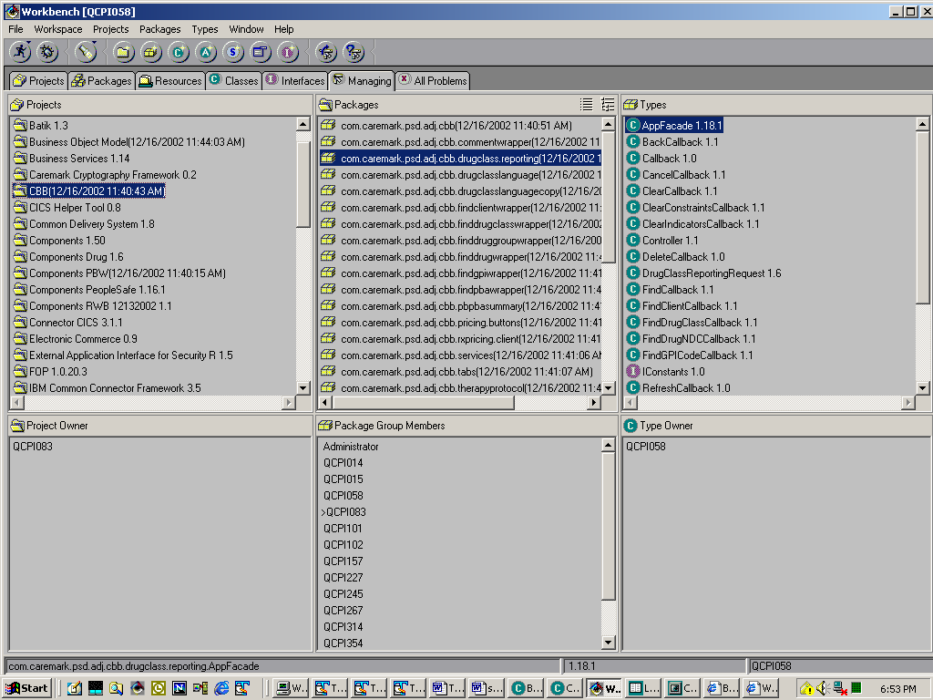

It’s the managing view which was shown to me by Casey Labedzki. I find it to be an infinitely more useful view to use. I have my own twist of it which looks like this:

What I did was to pull the horizontal bar to the bottom of the display so that I could see more project, package and class information as what’s in the bottom part isn’t that useful to me.

Double clicking on the AppFacade class (right hand side of the screen) in blue above displays the following screen which is maximized:

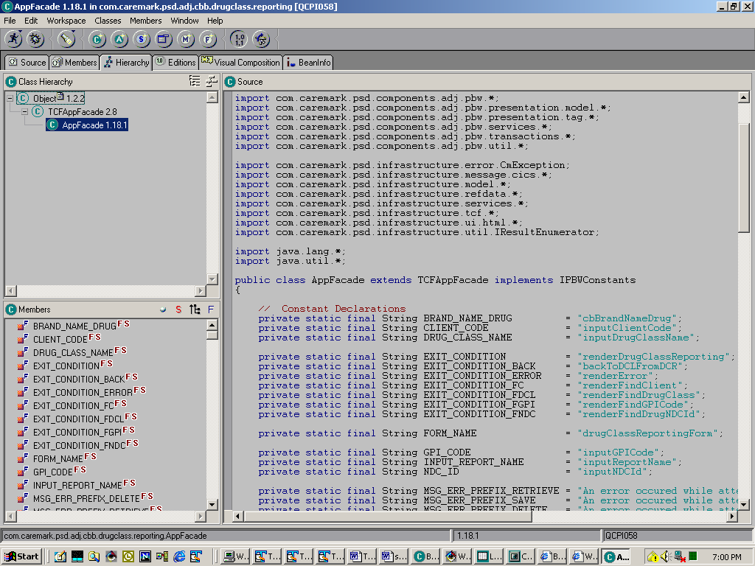

Now back to variables. You can declare variables using the Method wizard (Click on the M button), or directly on the AppFacade. You do this by typing in the variable in the ‘Source’ panel (the panel on the right hand side - see above), and typing Ctrl S to save. If you use the wizard, check the checkbox to access your variable with getter and setter methods which should be declared public. If you declare them directly on the AppFacade, right click on the variable name in the ‘Members’ panel to get this:

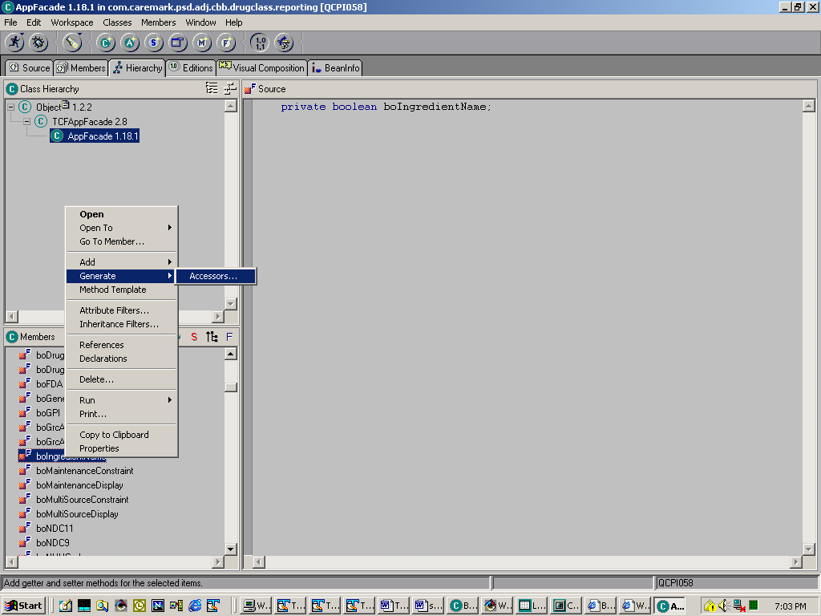

Then you will see this:

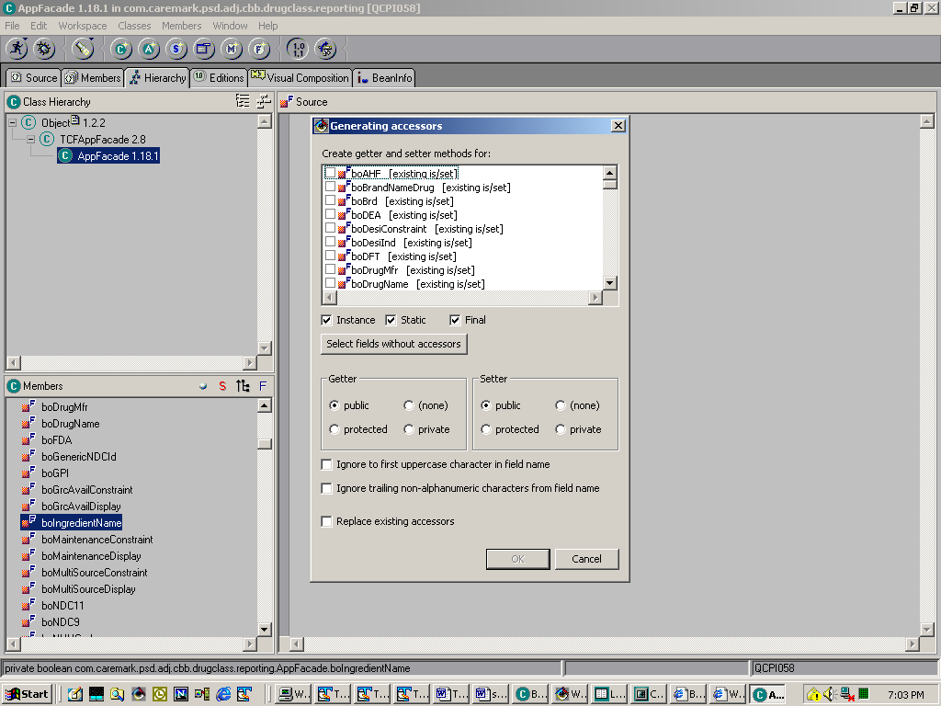

Check the checkbox by your variable in the list (scroll if needed) and click the okay button. It should generate you a getter and setter method for your variable.

One thing to pay attention to with the getter methods is what to do when the value is null. This can cause your JSP to blow up with the infamous Critical Systems Error null pointer exception. You can either check for nulls when you are invoking the getter method as in:

if (getWhateverField()!=null) { getWhateverField(); }

or do what Casey calls ‘lazy instantiation’ like so:

// method signature
public String getDisplayClientName() {
if(displayClientName==null) { setDisplayClientName(""); }
return displayClientName;
}

Here’s more about lazy instantiation from javaworld.com.

Here I’m actually using the setter method of said object to give it a default value of “” if it’s null.

Anyway, getters and setters are the recommended way to get and set variables on your AppFacade class.

The serviceMethod
Back when we talked about XML, we discussed a parameter called ‘serviceMethod’. In the examples I used, the serviceMethod was called doNothing. In this case, this method does exactly what it’s name implies – nothing. However, you need to declare a method on your AppFacade for each serviceMethod you declare in your XML, and most of them will do something. Here’s an example.

XML
<!-- ************************************************************************************ -->
<!-- Retrieve Client - invoked when inputClientCode is changed and successfully validated -->
<!-- ************************************************************************************ -->
<entryPoint widget="retrieveClientDCR"
method="com.caremark.psd.adj.pbw.drugclass.reporting.RetrieveClientCallback"
serviceMethod="retrieveClientDCR" callback="YES"
>

I am showing this method below in the AppFacade class. The source code lines on the right hand side are the contents of that method.

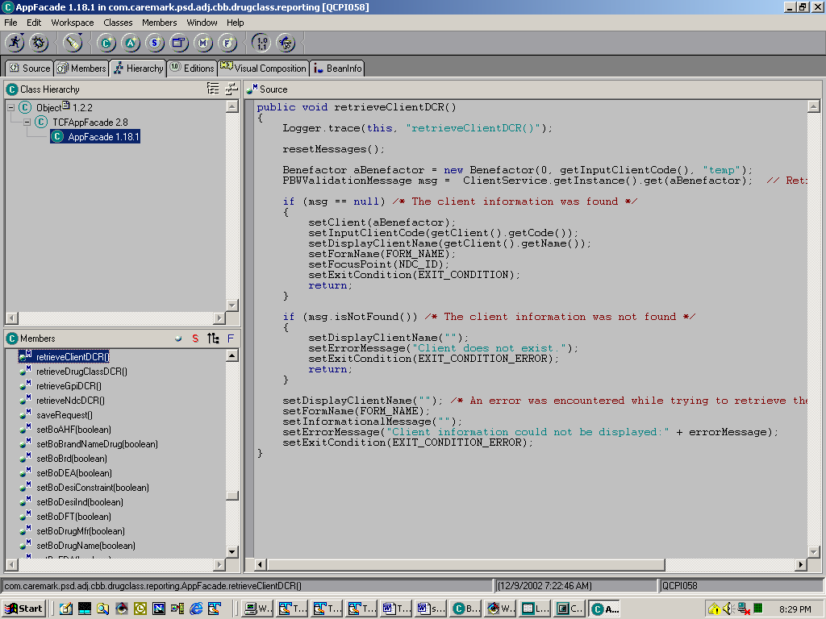

The point is that when you add a widget to your XML, you declare a serviceMethod that must correspond to a method declaration on your AppFacade.

To sum up AppFacade, your AppFacade class is the principal class that’s going to interact with your XML and JSP components. It’s also going to interact with your Service classes that control Requests and Transactions to the databases.

Callback Class(s)
I mentioned once before, and I will state it again here. Every package you create should have at least two Callback Classes. The 1st one is called Callback which is associated with your initial entryPoint widget (typically viewYourComponentCallback). The 2nd one,typically called the RenderCallback but doesn’t have to be, is associated with your render entryPoint widget (typically called renderYourComponent).

Purpose of the Callback Class
The callback has a processRequest method that does 6 things when you interact with it from your screen:
- Gets the request object which contains form/screen information
- executes the validate method described below
- maps the request object back to the façade along with any alterations to the request object that were performed in the validate method
- executes the service method defined in your XML (see XML section)
- executes the prepare results method described below using the appfacade and request classes as parameters
- performs exit point interactions which you hopefully defined correctly in your XML

The Callback class can almost always be created by creating a new Class in your package that has TCFCallback as a superclass (extends it). There’s nothing you need to add to it, it just needs to exist in your package.

The callback Class RenderCallback is a little different animal which brings me to my next topic – overriding Callback methods. Occasionally, you are going to want to override 2 speciffic methods in various Callback classes.

This is usually done when you are transferring from one component/screen to another one.

validate method
You override the validate method in a receiving Callback Class to find out information that was sent from a sending Callback Class. Here’s an example of that:

public boolean validate(TCFAppFacade argFacade, javax.servlet.http.HttpServletRequest req) throws TCFValidateRequestException
{
if ( super.validate(argFacade,req) ) {
try {
if (req.getAttribute("selectedClient") != null) {
((AppFacade)argFacade).setSelectedClient((Client)req.getAttribute("selectedClient"));
} else if ( req.getAttribute("findClientCancelled") != null ) {
((AppFacade)argFacade).findClientCancelled();
}
} catch (Exception ignore) {}
} else {
return false;
}
return true;
}

Basically, we’re checking to see if we passed in a client object, and if so, setting it to a reference on our AppFacade. If not, we’re checking to see if we cancelled out of the prior screen and if true, executing a method on the AppFacade called (not surprisingly) findClientCancelled.

Note the 1st line executes the validate method on the superclass. Always, always, always use this super.validate construct when you override this method. It will save you a lot of grief (from personal experience).

prepareResults method
You override this method when you want to send information to another screen/component.

public void prepareResults
(TCFAppFacade aTCFAppFacade, javax.servlet.http.HttpServletRequest req)
throws java.io.IOException {
aTCFAppFacade.setErrorMessage(null);
super.prepareResults(aTCFAppFacade,req);
req.getSession().removeValue(aTCFController.getAppFacadeTagName());
req.setAttribute("DRUGCLASSREPORTING_CANCEL", "");
}

Here, on our CancelCallback, we are doing some last minute cleanup; supering up (again, always do); removing this AppFacade; and then setting an attribute on the request to be picked up by the program that we are cancelling back to.

You can name the attributes that you set on requests to be whatever name you want. The only criteria is that the receiving Callback must use that exact same handle to get at the value. See the validate method above for how to get the attribute using the getAttribute method.

Controller Class
When I first started to draft this document, I thought there was more going on with this class than turns out to be the case. You need to have a Controller class in your package, but the Controller is pretty much a placeholder class. You need it because it gets referred to in the XML, but beyond that, it doesn’t do much. You can create this by extending the class TCFController.

Services Package
The services package contains service classes that work with your AppFacade class, Request classes, and Transaction classes to retrieve data. My observation has been that each Project has it’s own Service package. Check with your architect to see if this is true for your project. In the service package, each logical unit of work typically has it’s own service class, and each individual table object in UDB or DB2 MVS has it’s own service class too. This can mean that you have service classes calling other service classes.

The AppFacade is usually the class that instantiates and executes Service classes.

Lets take DrugClassReporting AppFacade. It does the following three steps:
- Instantiates the DrugClassReportingService.
- Executes the getDrugGroups() method from the service which takes in an action code, and an empty ‘collection object’ to contain the results of calling DB2 via a CICS transaction.
- Processes the results passed back from the Service which are now contained in the collection object.

Important Concept
The typical flow from the AppFacade to the service involves executing a method on the service and passing in some kind of empty object that will be populated by a successful execution of the transaction class associated with this service. In this instance, we are passing in a ‘container’ object to hold Drug Group rows retrieved by a cursor in the transaction executed by this service.

Example for CICS transaction
Anyway, AppFacade DrugClassReporting has a variable declared called (not surprisingly) DrugClassReportingService that’s really a service class. It executes a CICS transaction. Transactions executing CICS are more complicated propositions than transactions excuting UDB JDBCs or DB2 Stored Procedures. In the TCF, service classes for CICS transactions instantiate TCF Request classes which in turn execute TCF Transaction classes. On the next page is a screen print of this service.

The 1st thing to notice is the Final Static name declaration.
Then there are two constructor methods, a default constructor and a constructor that takes in a name parameter.

I am not sure the execute(Vector) is used for anything.

The getPrefix contains:
protected String getPrefix() { return "drugClassReporting"; }

You only need getSecurityKey if you are planning to implement a security scheme on this Class (see your architect). For now, let’s skip it.

Finally, there are two methods on the this Service Class that cause database interactions to occur.

createReportRequest(), and getDrugGroups().

Here’s what each contains:

createReportRequest

public PBWValidationMessage createReportRequest
( String requestType
, DrugClassReportingRequest drugClassReportingRequest) {
TCFLogging.info(bunch of logging info here);

// Return to calling program the results of instantiating a new A325 request object
return get(new A325Request(requestType, drugClassReportingRequest));
}

This method returns a PBWValidationMessage object to the caller which basically reports on the success or failure of the action. It takes a requestType in as a String and an object of type DrugClassReportingRequest.

1st it logs the request information, and 2nd it returns the result of a new object of type A325Request. This object takes in the same two parameters.

getDrugGroups
public PBWValidationMessage getDrugGroups
( String requestType
, DrugGroupOwnedCollection drugGroupOwnedCollection) {
TCFLogging.info(getAppName() + "." + this.getClass().getName(), "getDrugGroups()");

return get(new A325Request(requestType, drugGroupOwnedCollection));
}

This method behaves largely the same way the previous method does. The principal difference is that the requestType it passes into the A325Request object contains a different value.

Now that I’ve explained this service object a little bit, let’s look at how it’s called from the AppFacade class.

The Appfacade contains the following object declaration:

private transient DrugClassReportingService service;

Service objects should always be declared private transient. This is to prevent Service Classes from getting serialized. This appears to be a performance issue. Serialization writes to a database (session database?), which could bet expensive.

The AppFacade also contains a method called getDrugGroups() which is different from the method on the service.

Here’s the relevent snippet from that method.

private void getDrugGroups() {
if (listOfDrugGroups!=null) { return; } // Bail out if you already have a list of the groups
DrugClassReportingService service = getService();

// Process results upon successful execution of the service
if (!interpretServiceResponse(service.getDrugGroups(REQUEST_GROUPS
,getDrugGroupOwnedCollection()
), EXIT_CONDITION
, EXIT_CONDITION_ERROR
, MSG_ERR_PREFIX_RETRIEVE)
) { process results of successful execution }

The things to pay attention to here are:
Declaring a local instance of DrugClassReportingService name service that’s equal to the result of the getService method. This method is important and is described below.

After the local service method is instantiated, it has the method getDrugGroups (described above) executed with two parms passed in. Whenever you see something in caps like REQUEST_GROUPS above, you are looking at a hardcoded literal. The 2nd paramater is an empty collection that will be filled by the results of the transaction which retrieves a result set of Drug Groups from DB2.

The if clause is interrogating interpretServiceResponse which take in 4 parms: a service method, and 3 strings. If the result of the service method is good, the rest of the code takes the collection which should now contain some rows of drug groups and starts parsing thru them a row at a time and adding them to a Vector.

Now onto the getService method.

The method getService contains this:
protected DrugClassReportingService getService() {
if (service == null) {
service = (DrugClassReportingService)
((ServiceRegistry)ServiceRegistry.getInstance()).get(getServiceName());
}
return service;
}

If the service has never been instantiated it: gets an instance of the service registry; casts it as an object of type ServiceRegistry; casts that as an object of type DrugClassReportingService; and then does a get on that using the results of getServiceName as in input parameter.

Going one level deeper, getServiceName contains this:
public String getServiceName() {
return (String)this.getConfigParameters().get(DrugClassReportingService.NAME);
}

Remember back in the XML you defined something called a configParam? This method’s taking the NAME attribute off of the service and doing a lookup against all the configParams you defined in your XML.

If this seems painful and convoluted, that’s because it is. I remember spending hours trying to get this working right on a couple of occasions. You have to code a getService and a getServiceName method like this in your AppFacade class for your CICS transactions. Or something similar. I promise you, this is much easier for Midrange UDB JDBC/Stored Procedure services, and MVS Stored Procedure services. You can thank Casey for that.

Example of Service Class for UDB JDBC and Stored Procedures
This next part describes how this is done for a Stored Procedure using some concepts constructed by Casey. JDBC calls to the midrange uses the same convention.

Using the Basic Client AppFacade (Using com . caremark . psd . components . adj . pbw . client . basic . AppFacade for my example), here’s how these are different:

Instantiate the service, execute the get method which takes a Client object as a parameter, process result. Less fuss, less muss. None of this painful name-getting business that has to be declared properly in the XML to work. Note, I use the example of Client which really is an object of type Benefactor. Benefactor is an extension of Client.

Heres the relevent code snippet:
if (!isClientCodeValid()) /* Validate data */
{ . . .
return; // If invalid bails out here
}

// Instantiate new client (benefactor) object
Benefactor aBenefactor = new Benefactor(0, getClientCode(), "temp");

// Retrieve the client information
PBWValidationMessage msg = ClientService.getInstance().get(aBenefactor);

In the above line, Casey instantiates a validation message object, gets an instance of the service (uses lazy instantiation), passes in a client object, and executes the get method (retrieve data) all in one line of code.

if (msg == null) /* The client information was found */ {
. . .
return; // Bails out here if data was found
}

if (msg.isNotFound()) { /* The client information was not found */
...
Do a bunch of notfound logic
}

Now lets take a look at this Service class:

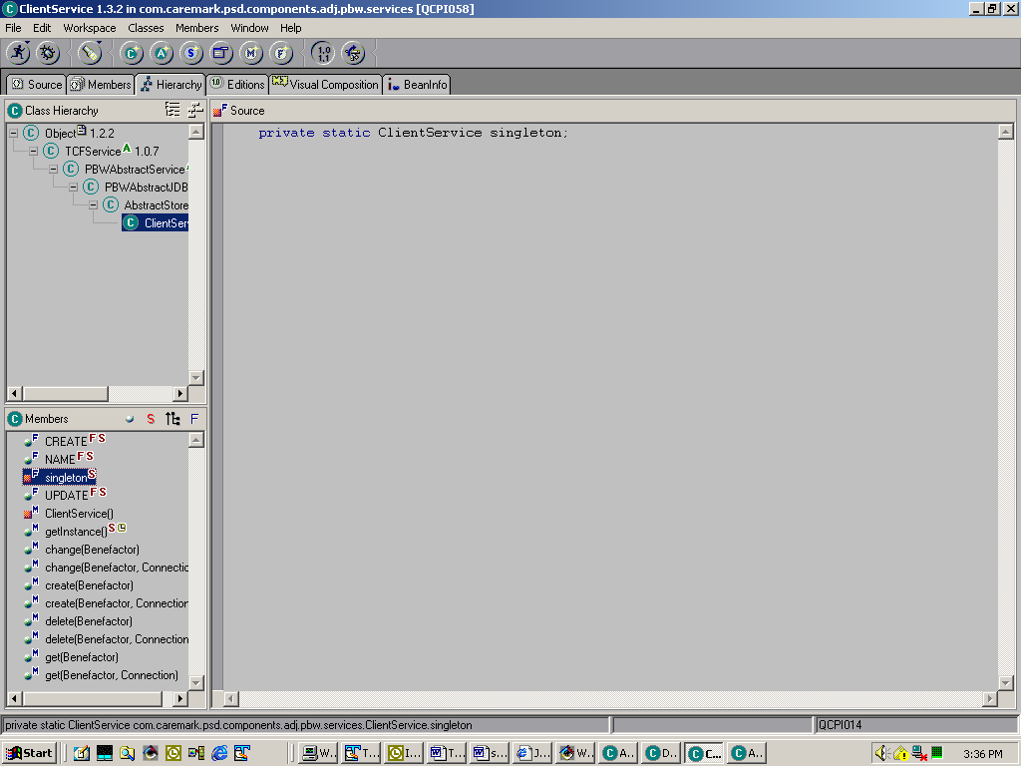

There are 4 fields, 3 are action codes and the last one is a Singleton instance of Client Service. Singleton is a Java Pattern javaworld.com-singleton used to ensure there’s only one instance of a class in existence at any given moment. It’s used to save resources. There’s a default constructor (ClientService()) and the rest of the methods all perform database actions with various parameters. Much easier to follow.

To sum up:
- Service classes are a layer between the Appfacade (sometimes other classes) and the Request/Transaction Classes.
- Service classes contain methods to execute different types of data interactions with UDB or MVS DB2.
- If you are coding up a new service class, it is an easier proposition to code up a UDB or MVS DB2 Stored Procedure service than an MVS CICS service. For this reason, you should strongly consider one of those two options (if possible) when developing new service classes.

Transactions Package
The transactions package contains Request classes and Transaction (big surprise) classes too. To access persistent data in the TCF, you need one of each. Interestingly, Request classes don’t do that much. They are similar to some Callback classes in that they appear to operate as placeholder classes. Necessary for the TCF to work right, but not very functional. Transaction classes on the other hand, are a different story. They interact with DB2 on the mainframe or on the midrange.

Building your request class CICS
The request class is not an extension of any class in the TCF. That is, it has no TCF superclass. There may however be a superclass in your project. The PBW project has one. Basically, all you need to code for it are the Constructor methods, whatever parameters that are going to be passed into it from the service, and the getter/setter methods for these parameters.

Here’s an example of a CICS Request class for PBW:

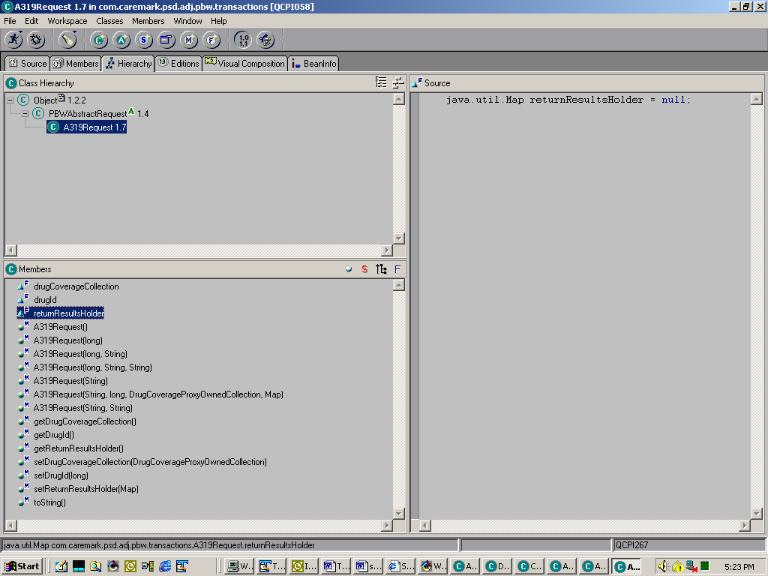

This request class A319Request extends the PBWAbstractRequest class, contains one field, two objects, seven constructors with various signatures, the getter methods for the attributes on the class, and the setter methods.

Building your transaction class CICS
Transaction classes are where the action takes place when performing database interactions. So far, I have identified three ways database interaction happens. To recap, from UDB JDBC calls to the midrange box, from CICS transactions to DB2 on the mainframe, and from DB2 Stored Procedures on the mainframe. Of the three, accessing the mainframe using CICS is the most difficult. I tried to find an easy one from our project to use as an example.

A309Transaction.

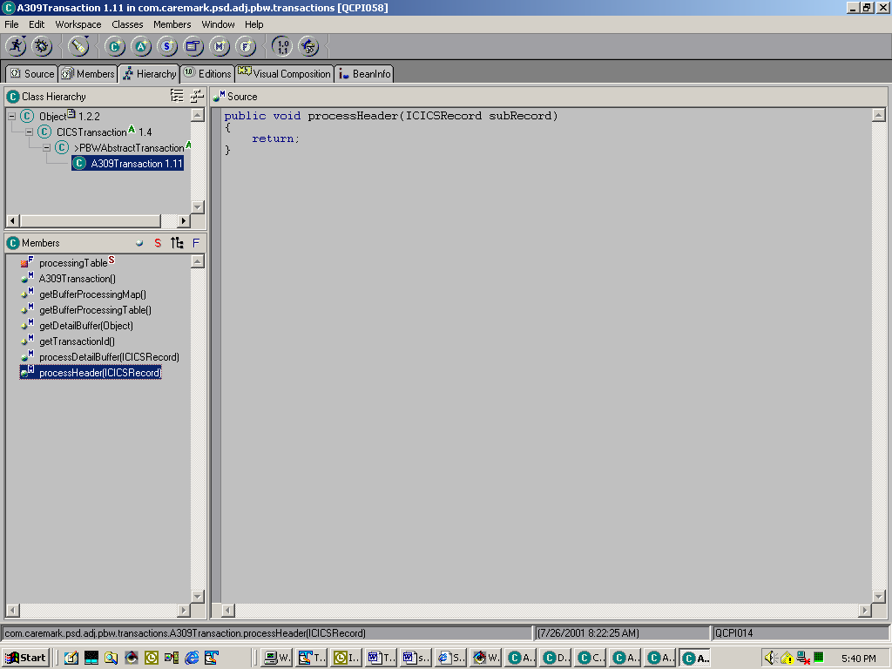

This components that appear to be necessary are:

processingTable
private static Map processingTable = null; I am not sure what this is for. However, all the CICS transaction classes appear to have it. Some use this construct instead - protected static Map PROCESSING_TABLE = null;.

getBufferProcessingMap
getter method for the above map object.

getDetailBuffer(Object)
This method (mandatory) prepares the request buffer that’s sent to CICS. The request buffer (and reply buffer) are defined in two properties files.
A309_Buffers.properties, and A309.properties.

Constructing properties files
Constructing the XXXX.properties file
You will need to define two properties files as well for any CICS transactions that you code. Use the naming scheme CICS transaction_Buffers.properties and CICS transaction.properties. In our case, the name of the CICS transaction is A309.

Your properties files should be located in the following subdirectory:
C:\appl\client_server\vers\resources\projects\yourProjectName\properties.

Here’s what these properties files look like.
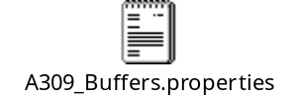

The 1st five lines and line 10 of A309.properties need a little more explanation.
- Put the size of your message here. This corresponds to your Commarea size in CICS.
- Contains the CICS Program name
- Contains the CICS transaction
- Contains the file name and buffer name for the reply buffer (what comes back from CICS).
- Contains the file name and buffer name for the request buffer (what you send to CICS).
10. Contains the default CICS transaction name which should be the same as
line 3 above.

Constructing the XXXX_Buffers.properties file
I believe you can construct your request and reply buffers in any order you please. The only requirement being that you do define each of every type of buffer you intend to use. You define every field in the buffer using four parameters: name, starting position, length, and datatype – 0 for characters and 2 for numbers. After you define all fields, you then put a line that contains the buffer name followed by: 0, comma, length, comma, 0, comma, 1st field name, comma, 2nd field name, comma, …, comma, last field name. Painful, time consuming and error prone.

Now back to getDetailBuffer(Object)

Here’s a code snippet with comments.

protected com.caremark.psd.infrastructure.message.cics.CICSRecord
getDetailBuffer(Object inputParm)
throws com.caremark.psd.infrastructure.error.CmException {

// Log relevent information in case it blows up so we can trace
com.caremark.psd.infrastructure.tcf.TCFLogging.info(getAppName() + "." +
this.getClass().getName(), "inputParm="+inputParm);

// Cast the Object coming in to an A309Request class
setCicsRequest((A309Request) inputParm);

/* Instantiate a CICSRecord class named detailBuffer using the properties defined in the A309
properties files. That’s what the BufferResourceManager, ResourceBundle, and CICSFieldParser are doing.
*/
CICSRecord detailBuffer =
new CICSRecord("REQ-A309-CLT-BUF",
getBufferResourceManager().asResourceBundle(),
new CICSFieldParser());

/* Set the field named REQ-A309-CLT-ID in the properties file to the value of Id on the A309
request Object
*/
detailBuffer.set("REQ-A309-CLT-ID",((PBWAbstractRequest)getCicsRequest()).getId());

// Continue setting fields defined in the request buffer in the properties file.
detailBuffer.set
("REQ-A309-CLT-MOR-DIS-PCG-IN",((A309Request)getCicsRequest()).getMailDiscontinueIndicator());
detailBuffer.set
("REQ-A309-CLT-PCS-DIS-PCG-IN",((A309Request)getCicsRequest()).getPaperDiscontinueIndicator());
detailBuffer.set
("REQ-A309-CLT-POS-DIS-PCG-N",((A309Request)getCicsRequest()).getRetailDiscontinueIndicator());
detailBuffer.set
("REQ-A309-CLT-HSU-TS",((A309Request)getCicsRequest()).getUpdateTimestamp());

// Pass the result back to the calling method in the TCF
return detailBuffer;
}

processDetailBuffer(ICICSRecord)
This method (mandatory) processes the results passed back from CICS.

Here’s the snippet with comments.

// Method signature – takes in an Interface of type ICICSRecord
public void processDetailBuffer(ICICSRecord subRecord) {

// log attempt at executing this method
Logger.trace(this, "processDetailBuffer(ICICSRecord subRecord): subRecord="+subRecord);

/* Instantiate a client (benefactor) object and set it’s reference to same object on the
Request class.
*/
Benefactor client = (Benefactor)((A309Request)getCicsRequest()).getClient();

/* Try to set the housekeeping object of client to the result passed back from CICS it appears
to always throw a NullPointerException which you don’t need to do. the important thing to understand is the line with the comment - This line.
*/
try {
IPersistentObject po = (IPersistentObject) client.getHousekeeping();
po.setUpdateTimestamp(subRecord.getTimestamp("RPL-A309-CLT-HSU-TS")); // This line
throw new NullPointerException();
} catch (NullPointerException ex) {
HouseKeeping hk = client.getHouseKeepingField();
HouseKeeping hk1 = new HouseKeeping(hk.getTableName(),
hk.getCreatedByUserID(),
hk.getCreatedByUserName(),
hk.getCreatedTimestamp(),
hk.getUpdatedByUserID(),
hk.getUpdatedByUserName(),
(Date)subRecord.getTimestamp("RPL-A309-CLT-HSU-TS"));
client.setHouseKeepingField(hk1);
}
setResult(client);
}
The basic scheme of this method is to instantiate an object passed in from the Request (passed in from the service, passed in from the AppFacade), and start using it’s setter methods to set attributes by using the getter methods from the ICICSRecord. That’s what subRecord.getTimestamp is doing. There should be a getter method on this Interface for each SQL datatype.

Request classes for UDB and Stored Procedures
These classes are basically the same except that they contain fields on the class that are the valid action codes. These action codes are used by their corresponding transaction classes to execute correctly.

Here’s the request class for the Client stored procedure.

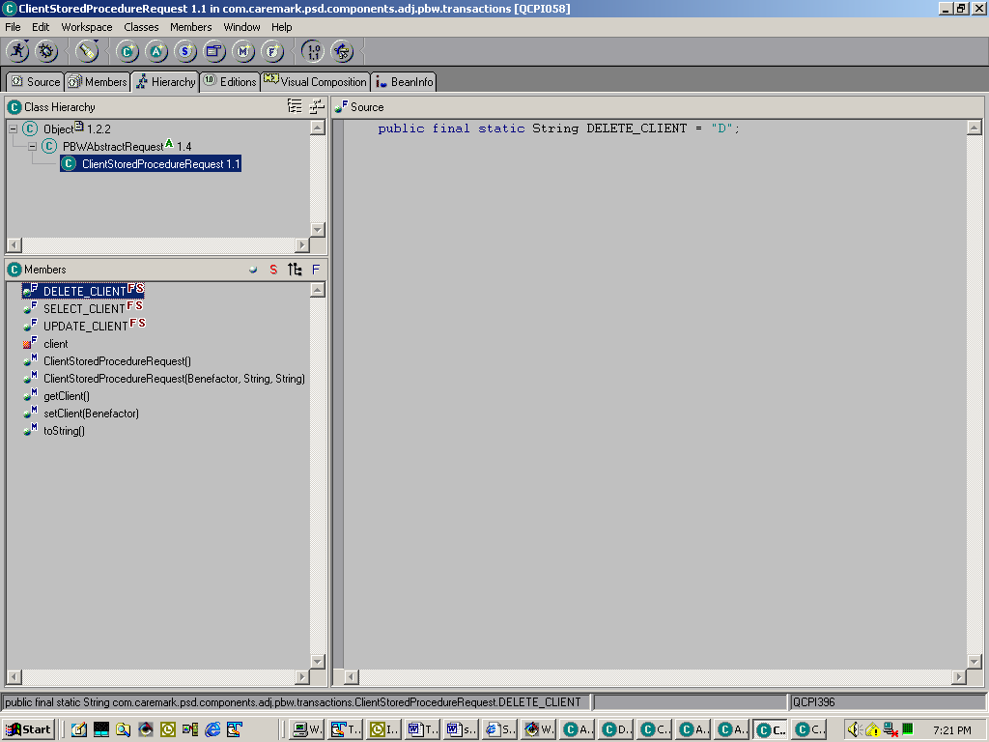

It contains three action code fields, one private object (client), two constructor methods with different signatures (the methods that say ClientStoredProcedureRequest), one getter method for client, one setter method for client, and a toString method (optional). Again, not to much to point out here except that you need to instantiate the request class with a correct action if you want the right results. UDB JDBC request classes can follow this same convention.

Note that this request class extends PBWAbstractRequest. If you are going to implement stored procedures in your project, you probably want to copy this over and make a couple of adjustments to properly reflect your project. In fact, maybe this needs to be a companywide abstract class. However in the interim, changing PBW to your project name/acronym should suffice.

Constructing Transaction classes for Stored Procedures
One immediate difference between Stored Procedure transaction classes and CICS transaction classes is that Stored Procedures do not use individual buffer property files (desireable) for each transaction. All the action takes place in the class. However, you do need two lines added to the SQLProperties.properties file declared for your project.



#
# This properties file contains properties used by PBWs JDBC transactions
#
Infra.qualifier=QCPDT3A
Infra.connection=Infra

Pbw.qualifier=pbw
Pbw.connection=Pbw

PbwDSN.qualifier=QCPDT3A
PbwDSN.connection=PbwDSN

The above two lines were added for Stored Procedure connections to DSN2 on the mainframe.

Heres a screen shot of Client Stored Procedure transaction
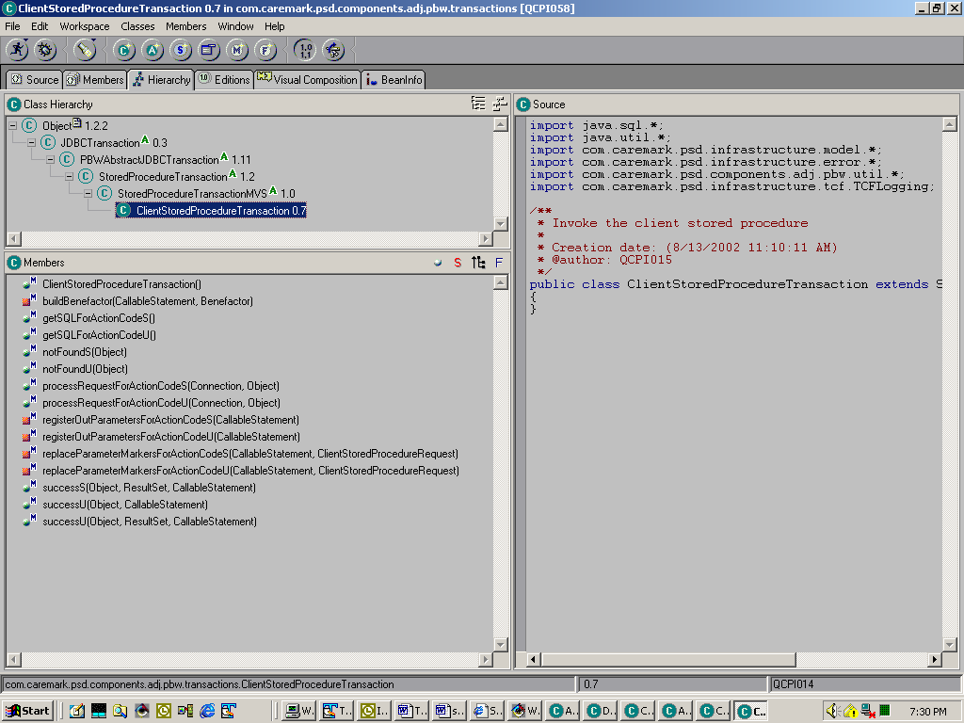

Notice for each action code are the following methods.

processRequestForActionCode#()
getSQLForActionCode#()
replaceParameterMarkersForActionCode#()
registerOutParametersForActionCode#()
notFound#()
success#()

We will look at each method for action S(elect).

processRequestForActionCodeS()
// Method Signature
public Object processRequestForActionCodeS(Connection connection, Object inputParm)
throws CmException {
// Log it
Logger.trace(this, "processRequestForActionCodeS(Connection connection, Object inputParm)");

// Declare an object of type CallableStatement – an object used for JDBC calls
CallableStatement cs = null;

// Declare in instance of the Request object and cast the input parm to it
ClientStoredProcedureRequest input = (ClientStoredProcedureRequest)inputParm;

try {
// set the cs to the results of the getSQLCodeForActionCodeS method
cs = prepareCall(prepareSql(getSQL(input.getAction())), connection);

// Replace the parameter markers in the SQL with values using this method
replaceParameterMarkersForActionCodeS(cs, input);

// Register the output parameters with this method
registerOutParametersForActionCodeS(cs);

// Instantiate a resultSet object and set it to the results of executing the query
ResultSet rs = cs.executeQuery();

// Executes either successS or notfoundS based on the SQLCode parameter passed back.
evaluateReturnCode(cs.getInt(25), input, rs, cs);
rs.close(); // Close the result set
cs.close(); // Close the callable statement

// Exception processing
} catch (SQLException sqlex) {
...
} catch (Exception ex) {
...
}

return null;
}

GetSQLForActionCodeS
public String getSQLForActionCodeS() {
return "call "+QUALIFIER_PATTERN+
".ADJSP011(?,?,?,?,?,?,?,?,?,?,?,?,?,?,?,?,?,?,?,?,?,?,?,?, ?)";
}
The name of the Stored Procedure is ADJSP011, and the qualifer_pattern is replaced at runtime by the system you execute against (QCPDT3A, PROD, whatever). The question marks are what as known as parameter markers. These are like host variables and get replaced at runtime by actual values. Some of them are input (must be replaced by values before executing a call to the Stored Procedure), some of them are output(must be registered as such before executing the Stored Procedure), and some of them are inputOutput(must have both of the foregoing operations performed on them).

replaceParameterMarkersForActionCodeS()
private void replaceParameterMarkersForActionCodeS(CallableStatement cs,
ClientStoredProcedureRequest input)
throws Exception {

cs.setString(1, input.SELECT_CLIENT); // Action Code
cs.setInt(2,0); // Client Id
...
cs.setShort(6,(short)0); // Settlement Indicator
...
cs.setString(17,"0"); // HSU User Id
cs.setTimestamp(18, new java.sql.Timestamp(new CmxDate().getTime()));
...
cs.setDate(21,new CmxDate().asMinimum().toSQLDate()); // Effective Date
}

In the above example, and the examples to follow, I chopped out repetitious code. You don’t need to see every setShort for example. Once is enough.

The CallableStatement object, and the Request object are passed into this method. It takes each ? mark by number and replaces it with a corresponding value using an appropriate datatype setter method. Note that some are set to zero. These are inputOutput variables which require default values before executing the Stored Procedure. We are selecting to get them, but because the Stored Procedure can also execute updates, we sometimes want these variables to be input. Rather than build two Stored Procedures, we opted to use one that can handle selects and updates. This approach required the use of inputOutput variables.

registerOutParametersForActionCodeS()

private void registerOutParametersForActionCodeS(CallableStatement cs) throws Exception
{
cs.registerOutParameter(2, Types.INTEGER);
cs.registerOutParameter(3, Types.CHAR); // Client Code
...
cs.registerOutParameter(5, Types.INTEGER); // CPG Id
cs.registerOutParameter(6, Types.SMALLINT); // Settlement Indicator
...
cs.registerOutParameter(14, Types.TIMESTAMP); // HSC TimeStamp
...
cs.registerOutParameter(21, Types.DATE); // Effective Date
}

Notice this starts with registering parameter 2. Because parameter 1 is input only. We don’t registerOutParameter input only variables.

notFoundS
public void notFoundS(Object aRequest)
{
setResult(getNotFoundMessage());
}

successS
public void successS(Object aRequest, ResultSet aResultSet,
CallableStatement aCallableStatement) throws Exception {
buildBenefactor(aCallableStatement, ((ClientStoredProcedureRequest)aRequest).getClient());
}

This method basically calls method buildBenefactor to set the values passed back from the Stored Procedure.

buildBenefactor()
private void buildBenefactor(CallableStatement cs, Benefactor aBenefactor) throws Exception
{
aBenefactor.setIdentifier((long)cs.getInt(2));
aBenefactor.setCode(cs.getString(3));
aBenefactor.setClientName(cs.getString(4));
aBenefactor.setName(aBenefactor.getClientName());
...
aBenefactor.setMailDiscontinued(new CmxBoolean(cs.getShort(7)).booleanValue());
aBenefactor.setHouseKeepingField(new HouseKeeping("TCLT", cs.getString(13), " ",
cs.getTimestamp(14), cs.getString(17), " ",
cs.getTimestamp(18)));
...
aBenefactor.setEffectiveDate(new CmxDate(cs.getDate(21)));
...
}

Observe that this method uses getter methods from the CallableStatment object to set attributes on the Client (benefactor) object for the various data types. Use this syntax for your objects.

Finally, observe how the superclasses of Stored Procedure transactions. This schema should probably be copied over into your project if you are going to use them. PBW should be changed to your project name, and the method

getDataSourceName
public String getDataSourceName() { return PBWDSN; }

in Class StoredProcedureTransactionMVS should be changed to your datasource.

Constructing a Transaction for UDB (JDBC)
PBW UDB transactions all have PBWAbstractJDBCTransaction for a superclass which in turn extends JDBCTransaction. It’s probably a good idea to have your own version of PBWAbstractJDBCTransaction for your project. Anyway, here’s a screenshot of PaperClaimsHistoryTransaction

The two fields, NEXT_ID_COLUMN_NAME & NEXT_ID_TABLE_NAME, are used for the insert function. You don’t need to implement this schema, but here’s what’s going on. PBW has a table called TCOLUMN_NEXT_ID. This table contains three relevant columns: TABLE_NM, TABLE_COLUMN_NM, & NEXT_ID. This table is used to get the next available id for id columns in other tables within UDB. You might want to think about declaring your tables using the datatype of Rowid instead. Another alternative would be to just get the max id as part of your insert statement when adding a new row.

Anyway, on to relevent methods. Observe the existence of getSQLForActionCode# methods and processRequestForActionCode# methods. These request types are defined in the PaperClaimsHistoryRequest class (see below).

We will look at the code for action code 9

// Takes in a connection object and an object as parameters
public Object processRequestForActionCode9(Connection connection, Object inputParm)
throws CmException {

// counter for result set
int fetchSize = 0;

// instantiate object PreparedStatement
PreparedStatement stmt = null;

// cast the object inputParm to object type PaperClaimsHistoryRequest
PaperClaimsHistoryRequest input = (PaperClaimsHistoryRequest)inputParm;

// Get the plan off the PaperClaimsHistoryRequest
PlanListing plan = input.getPlan();

String[] statuses = input.getStatuses();

// instantiate a Collection object and set it’s reference to same on the request object.
PaperClaimInformationOwnedCollection attrs = input.getAttributes();

// initialize it
attrs.clear();

try {
// Call the method getSQLForActionCode# here – see that method below
String sql = getSQL(input.getAction());

// Start replacing parameter markers with values from the request object
sql = StringUtility.replace(sql, "#PB_LISTING_ID#", String.valueOf(plan.getId()));
sql = StringUtility.replace(sql, IN, buildPromotionStatusInClause(statuses));
sql = StringUtility.replace(sql, "#EFFECTIVE_DT#",
plan.getEffective().toString("yyyy-MM-dd"));
sql = StringUtility.replace(sql, "#EXPIRATION_DT#",
plan.getTerminationDate().toString("yyyy-MM-dd"));

// prepare the statement
stmt = prepareStatement(sql, connection);

// instantiate a resultSet object and execute the query
ResultSet rs = stmt.executeQuery();

// Process the result set a row at a time
while (rs.next()) {
fetchSize++;

// instantiate a new PaperClaimInformation object
PaperClaimInformation a = new PaperClaimInformation();

// Start peeling off column values from the result set and set them to their
// corresponding values in the PaperClaimInformationObject
a.setEffective(new CmxDate(rs.getString("EFFECTIVE_DT")));
a.setExpiration(new CmxDate(rs.getString("EXPIRATION_DT")));
a.setPromotionStatus(new PromotionStatus(rs.getString("PROMOTION_STS_CD")));
...
a.setPharmNetwork(rs.getString("CSTM_PHM_NTWK_ID"));
attrs.add(a); // Add the attribute to the collection
}

// Close the resultSet object and the statement object
rs.close();
stmt.close();
}

// Exception processing
catch (SQLException sqlex) {
...
}
catch (Exception ex) {
...
}

if (fetchSize == 0) {
setResult(getNotFoundMessage());
}

return null;
}

// Contains the sql statement and uses parameter markers contained by # on either side
// called by above method in the line that’s bolded.
public String getSQLForActionCode9() {
return "SELECT PB_LISTING_ID, PROMOTION_STS_CD, EFFECTIVE_DT, EXPIRATION_DT, COB_IN
,COB_PB_ID, CVRG_NRSHM_IN, NRSHM_WAIVE_DAW_IN, NRSHM_WAIVE_PHM_IN, "

+ "NRSHM_WAIVE_DSP_IN, NRSHM_WAIVE_RFL_IN, CVRG_INTL_CLAIM_IN, INCLM_WAIVE_DAW_IN
,INCLM_WAIVE_PHM_IN, INCLM_WAIVE_DSP_IN, INCLM_WAIVE_RFL_IN, "

+ "EXPTR_CNTC_PFX_NM, EXPTR_CNTC_FST_NM, EXPTR_CNTC_MDL_NM, EXPTR_CNTC_LST_NM, "

+ "EXPTR_ADDR_LN1_TX, EXPTR_ADDR_LN2_TX, EXPTR_ADDR_LN3_TX, EXPTR_ADDR_LN4_TX
,EXPTR_CITY_TX, EXPTR_STATE_CD, EXPTR_ZIP_CD, EXPTR_ZIP_SFX_CD, "

+ "HYBRID_CD, IN_NETWORK_PEB_CD, OUT_NETWORK_PEB_CD, PC_PHN_PREAUTH_CD, CSTM_PHM_NTWK_ID"

+ " FROM "
+ QUALIFIER_PATTERN
+ ".TPLN_DSN_PPRCLM_HS WHERE PB_LISTING_ID = #PB_LISTING_ID# AND PROMOTION_STS_CD "
+ IN
+ " AND (EFFECTIVE_DT >= '#EFFECTIVE_DT#' AND EXPIRATION_DT <= '#EXPIRATION_DT#')";
}

That’s about all there is to it. When you create your Request and Transaction classes, you can either copy an existing one (typical) and modify the existing methods, or you can create one from scratch. Just try to follow the above guidelines to avoid excessive grief, and I think you’ll be alright.

Model Package
The model package is a package within your project package to contain business objects that are going to be used only within your project. If you create a Model that can be used by the entire company, it belongs in the Business Object Model Project. See CBOM below.

CBOM
CBOM is an acronym for Caremark Business Object Model. It’s stored in a project within Visual Age called Business Object Model. Anyway, the enterprise objects are stored here. Anytime you need to make a change to one of these objects, it can potentially impact the work of people in other groups. For this reason, you need to send out emails when you do it. If you are just adding attributes and their getter/setter methods, nothing more needs to be done. For changes beyond that, you need to discuss them with your team architect and any other groups that might be impacted by your change. Hence, the importance of sending out emails.

TCF & Infrastructure
These projects must be in your local repository, and they contain classes and packages necessary for the TCF environment to work. Beyond that, I don’t know what else to tell you. You just need to know that they are there.

Miscellaneous Notes

This stuff is geared towards PBW because I was making these as I went along. However, I think you can find them useful for your project as well. Also, there is more of an assumption that you know how to navigate around the IDE than in the previous parts of this document.

Setting up Screen transfers

This is going to be one of the 1st things you wind up needing to do after your basic JSP, javascript, XML, and java constructions. It’s necessary to have this working right before you can even get into your screen. The critical piece of getting the screen transfers set up right is in the XML. The other parts are fairly easy. I am going to use the DrugClassReporting function for my explanations here.

Entering
The DrugClassReporting is called from the Tools menu. Here’s a copy of that XML.

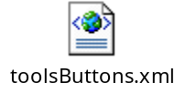

The issue is that in order to transfer into DrugClassReporting, things need to be set up correctly in this XML as well as drugClassReporting.xml (file is located in the XML section). 1st off, a button needs to be set correctly in the JSP and javascript.

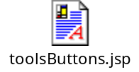

This JSP sets the widget directly in the button definition.

<%
// Execute java code to determine if the buttons should be displayed at all
if ( !aTCFAppFacade.isButtonsVisible()) {
return;
}

// check view security on this function
if(aTCFAppFacade.mayViewDrugClassReporting()){

// show button in ‘on’ mode when clicked
if(aTCFAppFacade.isDrugClassReportingOn()){
%>
// widget set directly in button definition
<a href="/clt/PBW?widget=drugClassReporting&sel=0">
<img src="/pbw/images/drugClassReporting_on.gif" border="0" alt="">
</a>

// show button in ‘off’ mode
<% } else { %>
// widget set directly in button definition
<a href="/clt/PBW?widget=drugClassReporting&sel=0">
<img src="/pbw/images/drugClassReporting_off.gif" border="0" alt="">
</a>

<%
}
}
%>
Here’s the relevent widget definition in toolsButtons.xml

<entryPoint widget="drugClassReporting"
method="com.caremark.psd.adj.pbw.tools.buttons.ViewCallback"
serviceMethod="viewDrugClassReporting" callback="YES">

<!-- This is an exitPoint under the ‘view’ entrypoint to the toolsButtons XML -->
<exitPoint name="renderDrugClassReporting">

<!—you should set the class to comp on the interaction method -->
<interactionMethod class="comp"

<!— Follow this scheme & widget to ‘vew’ widget in your component’s XML -->
method="?widget=viewDrugClassReporting&amp;sel=0"/>
</exitPoint>
</entryPoint>

We also have to code an exitPoint under the viewToolsButtons widget

<entryPoint widget="viewToolsButtons"
method="com.caremark.psd.adj.pbw.tools.buttons.ViewCallback"
serviceMethod="doNothing" callback="YES">

...

<!-- This exitPoint was referred to above -->
<exitPoint name="renderDrugClassReporting">

<!-- We want the buttons JSP to continue showing, so we have this interactionMethod -->
<interactionMethod class="jsp" method="/pbw/jsp/tools/toolsButtons.jsp"/>

<!-- Use this convention to refer to the ‘render’ widget in your component’s XML -->
<interactionMethod class="comp" method="?widget=renderDrugClassReporting&amp;sel=0"/>
</exitPoint>
</entryPoint>

Now in your components XML, you need to make entries under your ‘render’ widget, and your ‘view’ widget. The 1st widget we’ll look at is the render widget which contains this:

<!-- ************************************************************************************** -->
<!-- Render Entry Points -->
<!-- ************************************************************************************** -->
<!-- This was referred to from the calling XML -->
<entryPoint widget="renderDrugClassReporting"
method="com.caremark.psd.adj.pbw.drugclass.reporting.RenderCallback"
serviceMethod="doNothing" callback="YES">

<!-- This should be the 1st exitPoint under this entrypoint for readability -->
<exitPoint name="renderDrugClassReporting">

<!—interactionMethod class is jsp & method refers to your JSP -->
<interactionMethod class="jsp"
method="/pbw/jsp/tools/drugClassReporting/drugClassReporting.jsp">
</interactionMethod>
</exitPoint>

...
</entryPoint>

Here’s what the ‘view’ widget looks like:

<!-- entryPoint has the same name used in calling XML -->
<entryPoint widget="viewDrugClassReporting"
method="com.caremark.psd.adj.pbw.drugclass.reporting.Callback"
serviceMethod="doNothing" callback="YES">

<!-- Uses a mainframe CICS transaction -->
<service name="&appName;DrugClassReportingService"
class="com.caremark.psd.adj.pbw.services.DrugClassReportingService"
resource="&appName;drugClassReporting">
</service>

<!-- Points to 1st exitPoint under ‘render’ widget above observe the class & method -->
<exitPoint name="renderDrugClassReporting">
<interactionMethod class="comp" method="&startPainting;"/>
</exitPoint>

<!-- Also defined under ‘render’ entryPoint -->
<exitPoint name="renderError">
<interactionMethod class="comp" method="&startPainting;"/>
</exitPoint>
</entryPoint>

Back
DrugClassReporting is not a good function to use to describe coding a back button. I am going to use PlanCopy instead.



Here’s the relevent widget:

<entryPoint widget="cancelBackToCreateFromPlanCopy"
method="com.caremark.psd.adj.pbw.plan.copy.TransferCallback"
serviceMethod="transfer" callback="YES">

<!-- refers to exitPoint defined in current xml’s ‘render’ widget -->
<exitPoint name="transferToCreateFromCopy">

<!-- observe class and method (refers to widget in planDetail.xml) -->
<interactionMethod class="comp" method="?widget=planCreate&amp;sel=0"></interactionMethod>
</exitPoint>
</entryPoint>

Here’s the ‘render’ widget

<entryPoint widget="renderPlanCopy"
method="com.caremark.psd.adj.pbw.plan.copy.RenderCallback"
serviceMethod="doNothing" callback="YES">
<exitPoint name="transferToCreateFromCopy">
...

<!-- Observe the class and method (refers to ‘render’ widget in planDetail.xml) -->
<interactionMethod class="comp"
method="?widget=renderPlanDetails&amp;sel=0">
</interactionMethod>
</exitPoint>
</entryPoint>

Other

Every Night
Version up and release your work before you leave.

Every Morning
Replace your projects with the released contents. Often, other teammembers have made changes you need to pick up. Also, do a changeman refresh.

Before Repository Compacts
Version and release everything. Unversioned stuff gets deleted.
If you are not compiling JSPs externally, delete JSP Compiled project.
Backup your workspace!!!! – extremely important!!!!!
The 1st time you logon after the compact, it will take about 15 minutes to get in.

Restarting the Servlet Engine when you change components:
xml – yes
Property files – yes
Java – no
Javascript – no
Jsp – no, however if your jsp includes other jsp’s that you
made changes to, you need to make a cosmetic
change to the parent jsp so that Visual Age will
recompile it.

Introspection in the TCF
All objects in the AppFacade that are going to be set by introspection need a setter method. If it doesn’t exist, the value will not be set.

Pay careful attention to the setter methods for numeric and other nonString datatypes in the AppFacade. If there is an error because: a method does not convert a string; the method doesn’t handle a null value; or the field is actually not numeric; the introspect method will throw a numberFormatException and exit. No more introspection will take place, and if you don’t know about this problem, you won’t have a clue as to why the rest of your fields are not being introspected.

XML General Information

Callbacks
Your callback method names should approximate the function you are attempting to do. For example, renders should use RenderCallback. This avoids confusion.
Also, make one callback class for each event/action.

XML entry points have to be unique in our application. If one screen (XML) is using an entry point to another screen, any other XML should not declare that same entry point. For example we call Find Client from several screens. This event name should be different for each screen e.g. when calling from Client Basic screen it can be goToFindClientFromBasic and when calling from Drug Class Language screen it should be goToFindClientFromDrugClass.

RenderCallback
Put logic in this callback’s validate method to handle what happens when the user cancelled out of or selected an object from one of the ‘find reusable components’. Take a look at this for drugclass.reporting for an example.

EntryPoints
Entry points for XML. There needs to be two entrypionts.
Rendering – this one contains the reference to the JSP;

Entering – this one will have the start painting happens in this one. The exit point name should be the first exit point under the render widget defined above. Also, as a note exitpoints can have the same name as a widget. For example:

This guy should always be the 1st widget in the XML
<!----------------------------------------------------------------------------------------------------------------->
<!-- Render Entry Points -->
<!----------------------------------------------------------------------------------------------------------------->
<entryPoint widget="renderDrugClassReporting" method="com.caremark.psd.adj.pbw.drugclass.reporting.RenderCallback" serviceMethod="doNothing" callback="YES">
<exitPoint name="renderDrugClassReporting">
<interactionMethod class="jsp" method="/pbw/jsp/tools/drugClassReporting/drugClassReporting.jsp"></interactionMethod>
</exitPoint>
<exitPoint name="renderError">
<interactionMethod class="jsp" method="/pbw/jsp/tools/drugClassReporting/drugClassReporting.jsp"></interactionMethod>
</exitPoint>
</entryPoint>

It is probably desireable to make this guy the 2nd widget in the XML. Other XMLs should refer to this one when trying to transfer into your screen
<!------------------------------------------------------------------------------------------------------------------------->
<!-- Initial entry point -->
<!------------------------------------------------------------------------------------------------------------------------->
<entryPoint widget="ViewDrugClassReporting" method="com.caremark.psd.adj.pbw.drugclass.reporting.RenderCallback" serviceMethod="doNothing" callback="YES">
<exitPoint name="renderDrugClassReporting">
<interactionMethod class="comp" method="&startPainting;"/>
</exitPoint>
<exitPoint name="renderError">
<interactionMethod class="comp" method="&startPainting;"/>
</exitPoint>
</entryPoint>

TagFormation
Be careful with your tag formations.
This is okay, but it is probably more desireable to do it the other way.
<interactionMethod class="jsp" method="/pbw/jsp/tools/drugClassReporting/drugClassReporting.jsp"/>

Put a closing tag like below:
<interactionMethod class="jsp" method="/pbw/jsp/tools/drugClassReporting/drugClassReporting.jsp"></interactionMethod>

Note that if you change from
<configParam name="drugClassReportingServiceName" value="&appName;DrugClassReportingService"/>
to the above format, don’t do this!!!
<configParam name="drugClassReportingServiceName" value="&appName;DrugClassReportingService"/></configParam>

Make sure that 1st backslash comes out!!! It will screw you up good if you forget!!!!

Resources and xml
3 Entries are needed

The 1st resource entry defines the Transaction properties file and looks like this:
<resource
name="datasource.cics.A325"
basepath="projects/pbw"
startpath="projects/pbw"
pattern="properties/A325.properties">
</resource>

The 2nd resource entry defines the Buffers properties file and looks like this:
<resource
name="datasource.cics.A325_buffers"
basepath="projects/pbw"
startpath="projects/pbw"
pattern="properties/A325_Buffers.properties">
</resource>

The 3rd resource entry defines the application and goes below all of the transaction resource entries:

<resource
1 name="&appName;drugCoverageSummary"
basepath="projects/pbw"
startpath="projects/pbw"
2 pattern="services/drugcoveragesummary.properties">
</resource>

1 &appname contains PBW for our application. The part after the ; is the key to look up part 2. This is an FYI only,
you don’t need to worry about this.
2 This needs to be the name of your properties file for your service.

All of this stuff is now in PBW.XML which corresponds to yourProjectName.xml

I believe these entries are only needed if you are going to invoke a CICS transaction on the mainframe. If not, you can probably skip making an xml entry.

PBW.xml
For every new screen, 2 entries need to be created.
This under the entity section: <!ENTITY planCopy SYSTEM "planCopy.xml">
and this under the &resources; : &planCopy;

Debugging Javascripts
Put an alert(“a”) after the 1st line, alert(“b”) after the 2nd line, etc., etc. Don’t assume that by putting an alert at the end of the javascript which doesn’t pop up, that you are never entering the javascript.

One interesting Javascript bug that I have observed has to do with reinvoking a script. Sometimes the form.submit() function does not work a 2nd time. This can cause a lot of grief if you are counting on it to call something within the Appfacade. Operate on the Kim Fenn javascript principle – Do as little as possible that makes sense using javascript because it is a royal pain.

Passing data between Components
Passer
typically sets in the Callback class, prepare results method. Example: TransferCallback in drugCoverageDetail
Request (class httprequest) typically called req.setAttribute(string (key), object (that you are passing));

Important: If you override the prepareResults method, always have super.prepareResults(aTCFAppFacade,req); as the first line of executable code in the method.

Receiver
typically in the validate method of the Callback class req.getAttribute using the same key above. Typically you take that and stash it in your facade. See Callback in drugCoverageDetail

clearCallbacks/cleanCallbacks clean up all of those request attributes.

Initial processing should be done on the local drive (C), to avoid screwing up the other developers. When you are confident of the result, move your work to the network drive.

Totally different topic

JDBC
Using column functions such as Max or Count. In order for this to work, you need to use an alias for the column name:
ResultSet rs = createStatement(connection).executeQuery(prepareSql("select MAX(PBA_ID) as pba_id from qcpdt3a.TPBA_PBA"));
while (rs.next()) {
limit.setId(rs.getLong(pba_id));
}

or reference the column number:
ResultSet rs = createStatement(connection).executeQuery(prepareSql("select MAX(PBA_ID) from qcpdt3a.TPBA_PBA"));
while (rs.next()) {
limit.setId(rs.getLong(1));
}

Troubleshooting
Back to the top

Error 500
When this happens, check the class path and make sure you have the project in the classpath.

Unhandled error! You might want to consider having an error page to report such errors more gracefully
Check the class path and make sure you have all the projects you need selected.
If this doesn’t fix things, delete your JSP compiled code project from your workspace.

Unhandled error! You might want to consider having an error page to report such errors more gracefully
com.sun.jsp.JspException: C:\Program Files\IBM\VisualAge for Java\ide\project_resources\IBM WebSphere Test Environment\temp\JSP1_0\default_app\com\caremark\psd\infrastructure\tcf\TCFAppFacade.java:10: Package com.caremark.psd.infrastructure.security2 not found in import.
import com.caremark.psd.infrastructure.security2.*;
^
C:\Program Files\IBM\VisualAge for Java\ide\project_resources\IBM WebSphere Test Environment\temp\JSP1_0\default_app\com\caremark\psd\infrastructure\tcf\TCFAppFacade.java:11: Package com.caremark.psd.infrastructure.security2.ql not found in import.
import com.caremark.psd.infrastructure.security2.ql.*;
^
2 errors

To fix this, export the security project (In this example). (F)ile, (E)xport (D)irectory Next> You only need to select the .Java files on this menu. (F)inish. You might not need to restart the servlet engine, although I had a problem when I didn’t.

Sometimes this hoses things up hopelessly. When this happens, you need to go to the Lan PBW drive, subdirectory VAJava, subdirectory Backups, subdirectory IBM Websphere Test Environment and copy this over your c drive subdirectory of the same name.

Uncaught Servlet Exception
This is usually a problem with the JSP. Set a breakpoint in the ass-end of the compiled JSP in your JSP Page Compiled Generated Code. When you catch the exception, single step once. Most often, it will be a null pointer exception. Using the (S)elected (D)rop to selected frame command, restart at the top of this JSP. Using the Exception tab, Check the Null Pointer Exception. Then let the debugger (R)un until the debugger catches the exception. This will nail it down to where the problem occurs more often than not.

Error 500 Failed to load target Servlet
Start by looking in the Console to see what blew up

Instantiate com.caremark.psd.infrastructure.security2.html.LoginServlet
this one requires the creation of a root folder appllogs with subfolders: one for infrastructure and one for each of your projects like so:

Critical Error : java.lang.reflect.InvocationTargetException: java.lang.NullPointerException
Blows up on entry. This can happen when Service is gets moved from project to project and the person moving the components doesn’t thoroughly ensure that the dependent components will still work. Often times no notification is given either.

Critical Error Screen appears with other exceptions
Go to the debugger and click on the exceptions tab. Find the exception type and try to reload the screen. The debugger will trap the error right where it happens. Set a breakpoint right before this line and proceed to step through it with the debugger. Oftentimes this should help you find the problem.

Blank Screen appears upon transfer to New Screen
Component needs to be defined in the PBW.XML member.

JavaScript Error Script not found
We have observed an error where the JSP works fine on LocalHost, but doesn’t in TestA (Unix environment as opposed to NT). Check that your Javascript Naming convention follows the standard naming convention, particularly as related to InitCaps. Example. IsAlphaNumeric (correct) vs isAlphanumeric (not correct). This exact JS screwed me up good.

Also, it is possible to look at the components in the Test A environment through Serena Software. Under Areas, pick Quality Assurance. The JSPs and XMLs are contained in webcopta_systest_area and the javascripts are contained in webtest_systest_content.

Persistent Name Server won’t start
Check to see if you are trapping null pointer exception (or any other ones for that matter - a perfect example is SQLException) in the debugger. This one also screwed me up good one Saturday.

SQLException
What I discovered is that trapping SQLExceptions in the debugger does not work when you are pulling host variables out of a cursor result-set. In my particular instance, I didn’t include a column in the SQL that I was trying to set when I was processing the result-set. If you get a popup w/SQLException, and the debugger doesn’t catch it, this is a good place to start.

Unable to replace a Project with a newer version – just stops in mid-replace
This happens because of complications arising to project dependencies. Try deleting out the JSP Compiled projects first. Oftentimes, this can fix the problem – but not always. If this fails, try rebuilding the workspace from an old backup (assuming you are diligent about backing up your workspace – set a reminder in MS Outlook to do this on a weekly basis).

Visual Age environment keeps hanging up and/or crashing
One of the causes of this is deleting internally compiled JSPs (contained in the JSP Page Compile Generated Code folder). After about the 2nd/3rd/4th time, the system crashes, hangs up, or hangs up and crashes. Exit Visual Age after each internally compiled JSP delete. This appears to alleviate part of the problem anyway.

Out of Memory problems
Check your ide.ini file in this directory:
C:\Program Files\IBM\VisualAge for Java\ide\program

If the following 2 lines are not in this file, add them at the bottom (Thanks Rich Berkthold & Keith Patel for this recommendation).
[VM Options]
maximumMemoryLimit=400000000

More on this from a translated German version of the Va Java 4.0 redbook below.
Here ZZZ is the maximum number of BYTES, which may be assigned to the product. (example: maximumMemoryLimit=128000000 for an approximate storage limit of 128 MB). Beyond that it is to be noted that when treating OutOfMemoryError another behavior than the Sun J2SDK(TM) exhibits VM. The attempt to assign after spending the exceptional condition still many further objects can lead to the abrupt completion of the entire IDE. If you receive OutOfMemoryError messages, you should close the IDE and increase the maximum MEMORY limit.

Java
When testing the value of strings, use the .equals method of the String object.

Changeman DS
Adding and Attaching components
Go to development area and drill all the way down to the folder where the new component resides.
Right click and choose the Add to ECM Control option. It will give a list of Production Areas where you want to attach.
From the production area, you want to go to the production folder and click okay. It will prompt for a confirmation about adding it to source control. Click on yes.

Go to the production area and drill down to the right folder in the producation area.
Right click on the object again, and choose the attach option. Select the project for attaching. We have 2 PBW_062002_appl and PBW_062002_content.

Blank screen comes up. Check your exit conditions

Examining the logs on TESTB
Using hummingbird Neighborhood, for PBW drill down into \Webtest\dalwebtappllogs\pbw and look for pbw.log.clientSE or pbw.log.clientSEClone. You will need to synch up using the approximate time of your error.

Samson Boodala Notes

HTTP request – any request comes from HTTP Request.
- The parameters that are set on HTTP Request are set on the façade in the introspect method.
- It checks if the widget that’s being used in the reqeust is expecting interface parameters. If so, it will try to read the interface parameters. The method in question is the validate method. It appears on TCFCallback. Don’t override this method!
- Execute business logic if needed. For example, executing a CICS Transaction and processing/formatting the results.
- prepareResults method which can be overridden in the callback to do any custom processing or. For example one widget calls a 2nd widget on another screen. If the 1st widget needs to pass data to the 2nd widget, the data is set using this method either in the request or session level.
- invokeInteractions method – which usually renders a screen, but if there is nothing to render (you are in a sequence to call another screen) it will be a comptag.

Concluding Comments
This document is intended to help you get up to speed faster developing components in the TCF environment. I am sure that I have left useful things out, and that perhaps some parts are not as clear as they could be. Also, I probably made a few mistakes along the way. If you discover any of the above, or have a better way of doing something, please let me know. Let’s make this document the best that it can be!
Setting up Websphere notes

Adding data sources to your configuration
The PBW project needs the following datasources to run correctly: pbw, pbwdsn, infra, & drugman.

Here are the parameters to add starting with the line dataSourceName for each:
InstantDB - Version 3.13
Copyright (c) 1997-2000 Instant Computer Solutions Ltd.
Name : infra
ContextID : 542d90a0-00e6-f017-62b2-8d020428aa77
Property Name : ::Reference
Kind :
databaseName : null
dataSourceName : infra
driverImplClass : COM.ibm.db2.jdbc.app.DB2Driver
url : jdbc:db2:dsn2
minPoolSize : 1
maxPoolSize : 30
connTimeout : 300
idleTimeout : 1800
orphanTimeout : 1800
statementCacheSize : 100
description :

InstantDB - Version 3.13
Copyright (c) 1997-2000 Instant Computer Solutions Ltd.
Name : pbw
ContextID : 542d90a0-00e6-f017-62b2-8d020428aa77
Property Name : ::Reference
Kind :
databaseName : null
dataSourceName : pbw
driverImplClass : COM.ibm.db2.jdbc.app.DB2Driver
url : jdbc:db2:UDBPBWT
minPoolSize : 1
maxPoolSize : 30
connTimeout : 300
idleTimeout : 1800
orphanTimeout : 1800
statementCacheSize : 100
description :

InstantDB - Version 3.13
Copyright (c) 1997-2000 Instant Computer Solutions Ltd.
Name : pbwdsn
ContextID : 542d90a0-00e6-f017-62b2-8d020428aa77
Property Name : ::Reference
Kind :
databaseName : null
dataSourceName : pbwdsn
driverImplClass : COM.ibm.db2.jdbc.app.DB2Driver
url : jdbc:db2:DSN2
minPoolSize : 1
maxPoolSize : 30
connTimeout : 300
idleTimeout : 1800
orphanTimeout : 1800
statementCacheSize : 100
description : Connection for DB2 Stored Procedures

InstantDB - Version 3.13
Copyright (c) 1997-2000 Instant Computer Solutions Ltd.
Name : drugman
ContextID : 542d90a0-00e6-f017-62b2-8d020428aa77
Property Name : ::Reference
Kind :
databaseName : null
dataSourceName : drugman
driverImplClass : COM.ibm.db2.jdbc.app.DB2Driver
url : jdbc:db2:DSN2
minPoolSize : 1
maxPoolSize : 30
connTimeout : 300
idleTimeout : 1800
orphanTimeout : 1800
statementCacheSize : 100
description :

Heres another way you can get the parameters from the TCF:
- Add the project IBM Fixes (v1.2 as of this writing) to your workspace
- Select the project
- Select the package
- Select the class FIBM. After you complete 2-4, your workspace should look like this: 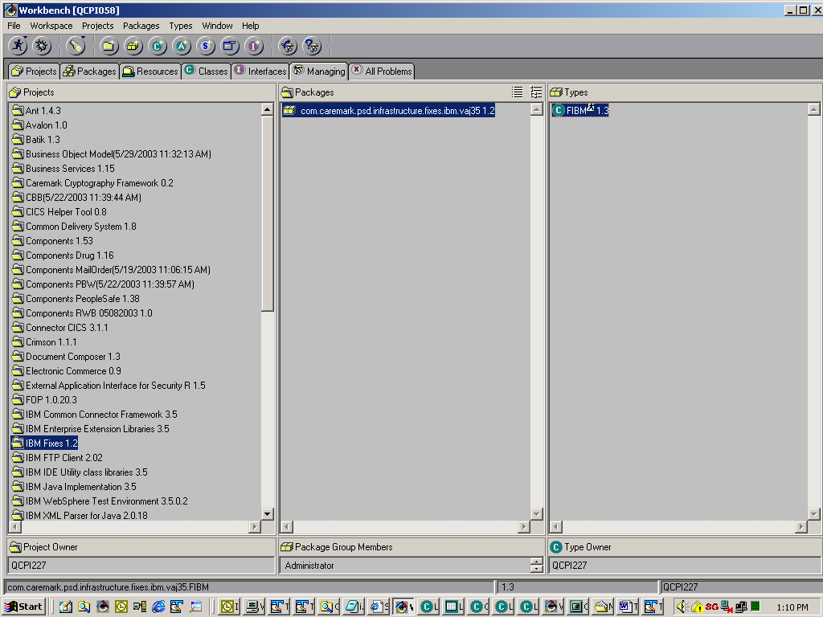

- Right Click on FIBM and select properties (the last option) 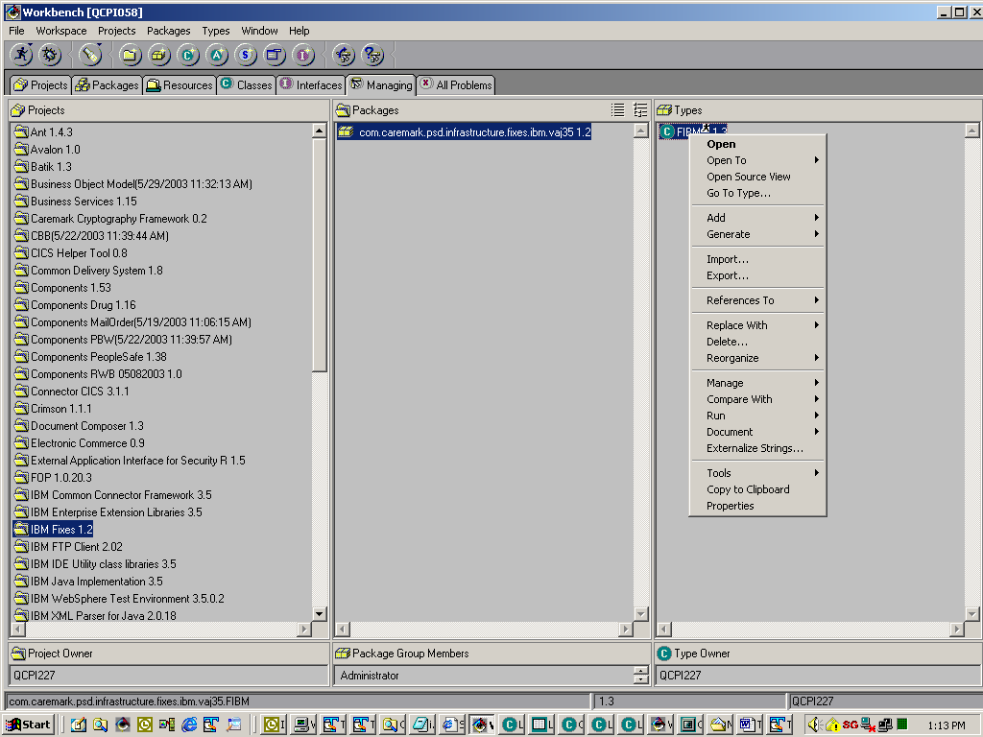
- Enter the datasource name preceded by –l 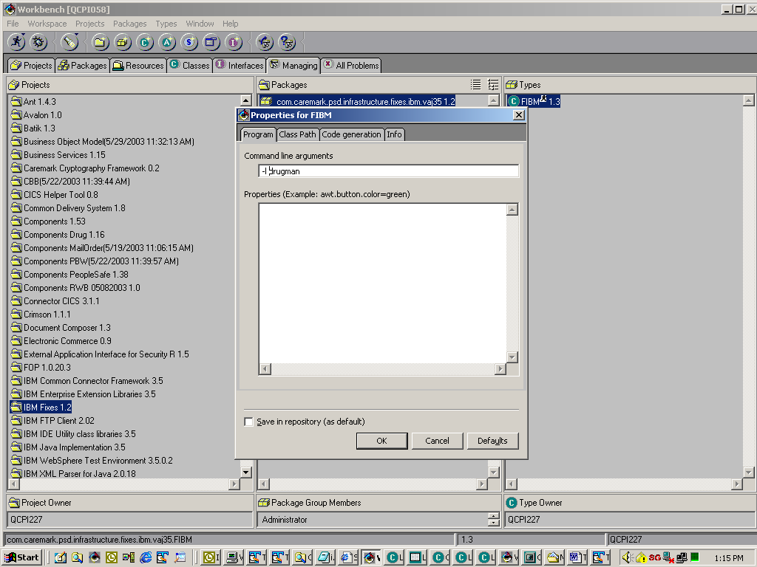

- Click okay
- Now click on the button that has the man running. It is the 1st button located just under the file toolbar option. 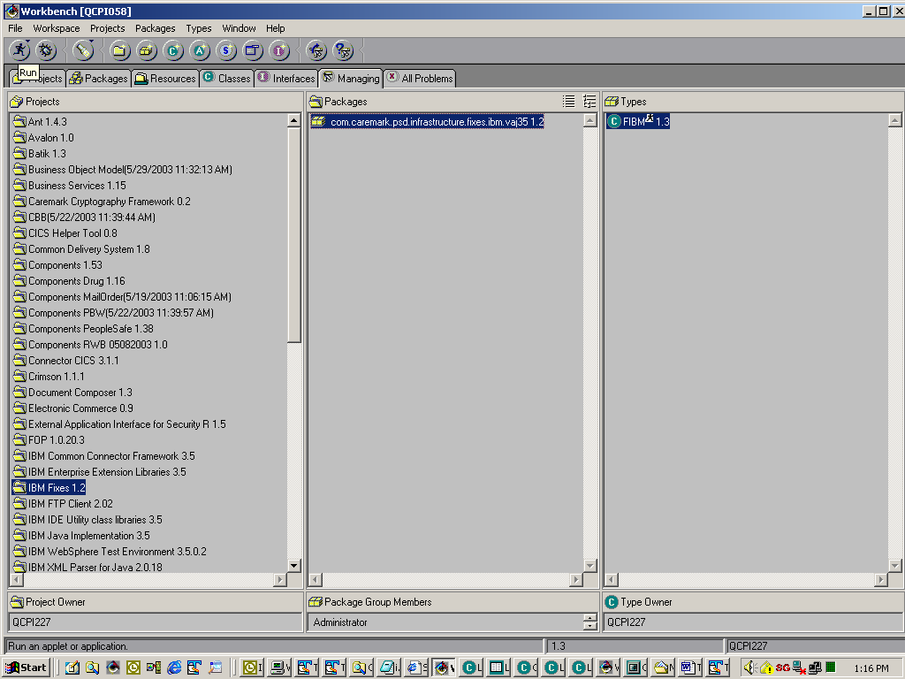
x

- After clicking this button, maximize your console window. In the screenprint above, this is the 4th button from the right. A result like the one below should appear: 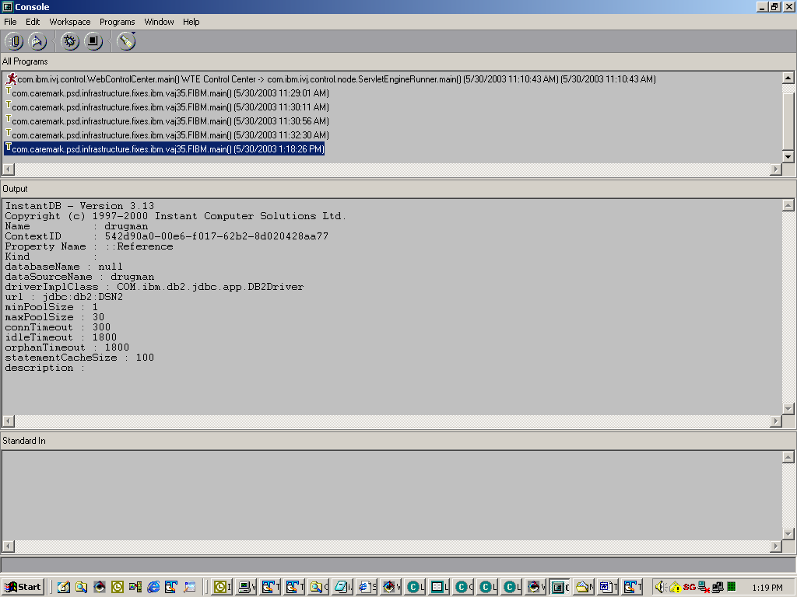

- Use the parameters starting with the dataSourceName to add your datasource to the websphere test environment.

Sybex. HTML complete 2nd edition (Alameda, Ca. 2000), p. 914
2 Sybex. HTML complete 2nd edition (Alameda, Ca. 2000), p. 915
Sybex. HTML complete 2nd edition (Alameda, Ca. 2000), p. 893
WROX, Professional Java Server Programming J2ee edtion (Birmingham, UK 2000), p. 1497

